**Poly-substance use, treatment completion, and contact with the justice system: a multistate analysis of treatments for substance use disorders between 2010-2019, Chile**

Andrés González-Santa Cruz a.b,c; José Ruiz-Tagleb,c Mariel Mateo Pinones b,d; Álvaro Castillo-Carniglia b,c,e;

a Doctoral Program in Public Health, Institute of Population Health, Faculty of Medicine, Universidad de Chile, Independencia 939, Independencia, Santiago, Chile

b Millennium Nucleus for the Evaluation and Analysis of Drug Policies (nDP), Chile.

c Society and Health Research Center, Facultad de Ciencias Sociales y Artes, Universidad Mayor, Santiago, Chile.

d School of Criminology and Criminal Justice, Griffith University, Australia

e Millennium Nucleus on Sociomedicine (SocioMed), Chile.

# Bibliografía

# 

# 

## An Ultimate Guide to Matching and Propensity Score Matching

# <https://towardsdatascience.com/an-ultimate-guide-to-matching-and-propensity-score-matching-644395c46616> Leihua Ye, PhD Jun 18, 2021

# 

# 

* No siempre es posible es hacer RCT por problemas prácticos y éticos
* Tenemos 2 alternativas cuando no podemos hacer aleatorización a nivel individual: quasi-experimental u diseños observacionales

## Shirley, K. E., Small, D. S., Lynch, K. G., Maisto, S. A., & Oslin, D. W. (2010). Hidden Markov models for alcoholism treatment trial data. In The Annals of Applied Statistics (Vol. 4, Issue 1). Institute of Mathematical Statistics. <https://doi.org/10.1214/09-aoas282>

* Ojo: en ensayo clínico
* The HMM is an attractive alternative to the first-order Markov model because its serial dependence structure allows for longer-term dependence.
* Modelo dirigido por parámetros: hay un proceso subyacente o proceso de parámetro que determina la distribuión de ciertos parámetros en el tiempo
* Modelos dirigidos por observación, en cambio, modelan resultados observados en función de resultados previamente observados
* Segundo, tiene interpretación clínica ya que se basa en el modelo de recaida comportamental: condición mental de estrés o físico, situación de alto riesgo
* relapse is not necessarily an observable state—it is a hidden state that presumably leads to heavy drinking with higher probability than other states, but not with certainty

## King, C. A., Englander, H., Korthuis, P. T., Barocas, J. A., McConnell, K. J., Morris, C. D., & Cook, R. (2021). Designing and validating a Markov model for hospital-based addiction consult service impact on 12-month drug and non-drug related mortality. PloS one, 16(9), e0256793. https://doi.org/10.1371/journal.pone.0256793

## r Hubbard et al. (2003), quienes muestran una disminución en actividades ilegales para quienes asistieron a tratamientos residenciales, no así en los ambulatorios.

## Price, O., Sutherland, R., Man, N., Bruno, R., Dietze, P., Salom, C., Akhurst, J., & Peacock, A. (2023). Trends and psychosocial correlates of same day polysubstance use among people who inject drugs in Australia, 2012-2022. In International Journal of Drug Policy (p. 104150). Elsevier BV. https://doi.org/10.1016/j.drugpo.2023.104150

* Policonsumo: consumir más de una sustancia en una ventana de tiempo, ya sea concurrentemente (por separado) o simultáneamente. Hay ambiguedad en al definición, pero a pesar de eso, es un comportamiento común en consumidores.
* las razones de policonsumo puede ser para un efecto aditivo (más del mismo efecto) o sinérgico (distintos efectos se potencian) o contrarrestar el del otro
* el policonsumo puede ocurrir de un mercado contaminado con otras sustnacias ( 10.24095/hpcdp.42.2.01)
* la ventana de tiempo es muy heterogénea, ellos operan con el simultáneo en el día, porque es indicador de resultados más a largo plazo y agudos (10.1038/s41380-020-00949-3)
* Otra dificultad es la interminable mezcla de distintas sustancias y combinaciones (impossibly large). Una forma pragmática de combinarlas es ver combinaciones que tienen efectos negativos e impactos en la población.
  + Las combinaciones de drogas que involucran opioides, ansiolíticos y estimulantes son de particular preocupación.
  + El policonsumo de estas drogas puede causar una presión significativa en los sistemas cardiovascular y respiratorio, y se ha asociado con un mayor riesgo de sobredosis fatal.
  + Las personas que participan en el policonsumo de drogas también son más propensas a participar en otros comportamientos de alto riesgo, como compartir agujas e inyectarse drogas con más frecuencia.
* **Método**: who completed a survey between 2012-2022. exposición: five mutually exclusive profiles: opioid-depressant, opioid-stimulant, stimulant-depressant, opioid-stimulant-depressant, and single drug class use.
  + people who identified as non-binary or gender fluid were excluded due to small numbers that resulted in zero cells for some combinations of risk factor and outcome variable levels [n=39] (Greenland et al., 2016))
  + Análisis: UpSet plot, which allows visualisation of data with more than three sets (i.e., >3 drugs), to describe patterns of polysubstance; multinomial logistic regression and considered single drug class use the referent group. ; In a sensitivity analysis, we used a complete case approach to re-estimate the multinomial logistic regression model.
* **Resultados/Discusión**: polysubstance use is associated with multiple disadvantage
* Limitaciones: We used a very specific definition of polysubstance use (i.e., use of more than one of three drug classes), which may limit the comparability of our study. We were also unable to distinguish between concurrent and simultaneous (...)recall bias

## Karamouzian, M., Pilarinos, A., Hayashi, K., Buxton, J. A., & Kerr, T. (2022). Latent patterns of polysubstance use among people who use opioids: A systematic review. The International journal on drug policy, 102, 103584. https://doi.org/10.1016/j.drugpo.2022.103584

* Person-centered analytical approaches (e.g., latent class analysis) provide a holistic understanding of individuals’ substance use patterns and help understand PSU heterogeneities among
* Belonging to higher frequency or severity PSU classes were associated with frequent injection drug use, sharing needles and paraphernalia, high-risk sexual behaviours, as well as experiences of adversities, such as homelessness, incarceration, and poor mental health
* **Introducción**: 2>= sustanacias distintas o clases de sustancias por separado o simultáneo. PSU es muy común en consumidores de opioides. A pesar de las inconsistencias de lo que constituye PSU, los estudios han asociado PSU con un mayor riesgo de estados de salud. Considerando la importancia de caracterizar la distribución y correlatos de policonsumo para intervenciones, los desarrollos metodológicos han buscado identificar mejor y descubrir subpoblaciones con distintos patrones de policonsumo mediante métodos centrados en la persona.
* Estos métodos examinan los datos de manera inductiva, analizando los patrones de respuesa a indicadores que miden prácticas especificas de uso, y revelan tipologías no observadas o clases de PSU mediante métodos reproducibles y transparentes estadísticamente.
* de 3372 artículos, 30 cumplen con criterios de inclusión
* **Resultados**: Operacionalización de PSU: diagnóstico de dependencia o SUD, uso en años de vida, últimos 6 meses, último mes, y combinaciones de curso de vida con ultimos meses.
* Indicadores de resultado: variables binarias (la mitad)
* Incluyen otros indicadores como edad, sexo, raza, condiciones de salud mental, salud física, tenencia de la vivienda, tipo de sustancia (frecuencia de uso, edad de inicio), ruta de admnistración (inyectada o no), marcas de opioides.
* Predictores: membresía a la clase y edad relativamente consistentes; con sexo, inconsistente (mujeres: peor salud mental, tabaco y canabis y anfetaminas; hombres: alcohol, buprenorfina y benzo, psicopatología, sobredosisheroina); con etnia/raza, inconsistente (negros e hispánicos, más inyectado)
* Resultados relacionados con membresía a una clase: servicios psiquiátricos, salud mental, resultados relacionados con drogas, trombosis, comportamiento violento, conductas sexuales, encarcelamiento, desempleo.
* **Discusión**: Predictores de membresía en distintas clases de policonsumo, desde patrones de consumo hacia exposiciones de nivel socio-estructurales (encarcelamiento, hospitalización). Limitaciones: mucho diseño transversal, trae preocupaciones sobre el sesgo de temporalidad y establecer causalidad. Otros estudios no se fijaron en asociaciones y reportaron soluciones de manera meramente descriptiva

## Bhondoekhan, F., Li, Y., Gaither, R., Daly, M. M., Hallowell, B. D., Chambers, L. C., Beaudoin, F. L., & Marshall, B. D. L. (2023). The impact of polysubstance use patterns on engagement of substance use disorder treatment among emergency department patients at high risk of opioid overdose. In Addictive Behaviors Reports (Vol. 18, p. 100512). Elsevier BV. https://doi.org/10.1016/j.abrep.2023.100512

* Additionally, polysubstance use is associated with greater difficulty accessing and remaining in substance use disorder (SUD) treatment.
* El policonsumo se asocia con más dificultad para acceder y permanecer en tratamientos por trastornos por uso de sustancias.
* Es un sub-análisis de un RCT que compara dos intervenciones para individuos en departamentos de emergencia (ED)
* Igual se sae poco del impacto de policonsumo en retención en tratamientos por SUD en aquellos que van a EDs con alto riesgo de sobredosis
* Es necesario entender el rol del policonsumo en el entorno de emergencias para informar mejores prácticas para cuidar por esta población de mayor riesgo.
* Dada la heterogeneidad de patrones de consumo en esta poblaciónd e pacientes, una aproximación dirigida por los datos se utilizó para identificar clasificaciones de uso de sustancias y su relación subsecuente en mantenerse en tratamiento por SUD.
* Initial class enumeration was conducted by estimating models with increasing numbers of classes until information criteria showed worsening model fit, without inclusion of covariates.
* determination of the best fitting model was based on comparison of four model fit statistics: entropy, Bayesian Information Criteria, Akaike's Information Criteria, and bootstrapped likelihood ratio tests. In the event that there was disagreement between the indices of fit, preference was given to the bootstrapped likelihood ratio tests
* Using the three-step LCA approach, participants were assigned to the class with their highest probability of membership, and the primary outcome was regressed on the latent class variable. Covariate adjustment included a variable for intervention arm and other variables known to be associated with polysubstance use and healthcare access among vulnerable populations. These variables were added into the model in the following sequential order
* To avoid overfitting, only statistically significant covariates for social determinants of health were carried over to the final model that included covariates for demographics and SUD treatment need or history.
* Descriptive statistical analyses were conducted using SAS version 9.3 (SAS Institute, Inc; Cary, NC) and the LCA approach was conducted in Mplus version 8.8 (Muthen & Muthen; Los Angeles, CA
  + Age: continuous variable
  + Gender identity: categorical variable with two categories (Woman and Man)
  + Race-ethnicity: categorical variable with four categories (White, non-Hispanic; Black, non-Hispanic; Hispanic, any race; Other, non-Hispanic)
  + Marital status: categorical variable with two categories (Single or widowed and Married or with partner)
  + Completed high school education: categorical variable with two categories (No and Yes)
  + Health insurance: categorical variable with two categories (No and Yes)
  + Unstable housing in past six months: categorical variable with two categories (No and Yes)
  + Currently employed full or part-time: categorical variable with two categories (No and Yes)
  + Current monthly income: categorical variable with two categories ($0–$1500 and >$1501)
  + Past six-month substance use: categorical variable with 10 categories (Prescription opioids, Prescription benzodiazepine, Cannabis, Crystal methamphetamine, Cocaine, Heroin, Club drugs, Heavy episodic alcohol use, Injection drug use, Opioid overdose in past 12 months)
  + Prior SUD treatment (past one-month): categorical variable with two categories (No and Yes)
  + Ever received methadone treatment: categorical variable with two categories (No and Yes)
  + Ever received Suboxone™ treatment: categorical variable with two categories (No and Yes)
  + Ever experienced barrier to treatment access: categorical variable with three categories (No, Yes, and Don’t know/Refused)

## Rodríguez-Cano, R., Kypriotakis, G., Cortés-García, L., Bakken, A., & von Soest, T. (2023). Polysubstance use and its correlation with psychosocial and health risk behaviours among more than 95,000 Norwegian adolescents during the COVID-19 pandemic (January to May 2021): a latent profile analysis. In The Lancet Regional Health - Europe (Vol. 28, p. 100603). Elsevier BV. <https://doi.org/10.1016/j.lanepe.2023.100603>

* Noruegos , 97,429 adolescentes 13-18. Los correlates incluyeron variables psicosociales, comportamientos de riesgo a la salud y problemas relacionados con el COVID-19
* **Introducción**: Policonsumo adolescente: más riesgo de desarrollar problemas de salud física y mental; aplican latent profile analysis
* se asocia a problemas de conducta, consumen más los mayores, más problemas físicos (dolor de espalda y cabeza) y mentales; alto consumo de alcohol y tabaco se asocia con menos consumo de fruta y vegetales y actividad física
* **Métodos**: Se categoría por la frecuencia a cada sustancia
* bootstrapped likelihood ratio test value (BLRT). Statistically significant results indicate that the K profile model fits the data better than the K-1 profile mode
* Average Posterior Probability (AvePP)

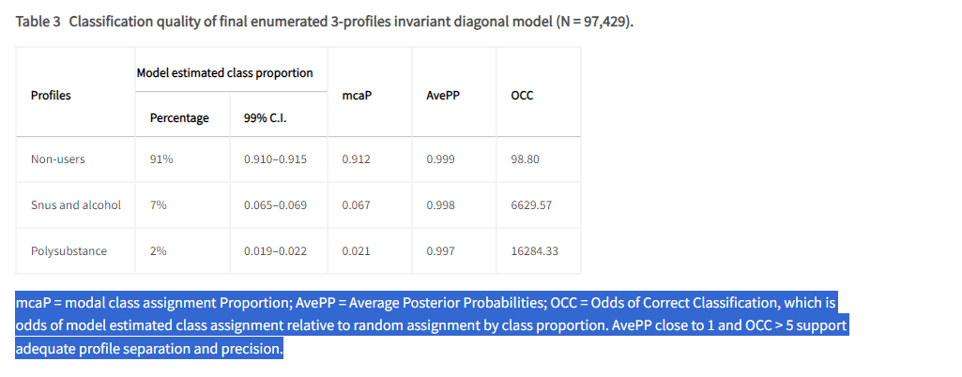

* Table 4Results of multinomial logistic regression analyses of the associations between measures in various domains of adolescents’ lives and latent substance use profiles.

## Mefodeva, V., Carlyle, M., Walter, Z., Chan, G., & Hides, L. (2022). Polysubstance use in young people accessing residential and day-treatment services for substance use: substance use profiles, psychiatric comorbidity and treatment completion. Addiction (Abingdon, England), 117(12), 3110–3120. https://doi.org/10.1111/add.16008

* Distintas combinaciones de uso de sustancia y problemas de salud mental requieren distintas aproximaciones a tratamiento. Nuestro estudió busca identificar clases de sustancias compartidas entre jóvenes a la admisión, detemrinar qué problemas de salud mental, calidad de vida y servicios estabanm asociados con las clases identificadas, y determinar qué clases y servicios (residential or day‐programme) eran más probables de completar tratamiento.
* Cross-sectional and prospective study using service and outcome data
* Identifican a policonsumidores de amplio espectro, primariamente anfetamina, alcohol y canabis. Los de amplio espectro tenían más chance de síntomas psicóticos, doble de chances de residencial que los por anfetamina
* Informar derivaciones (referral pathways) y desarrollar aproximaciones de intervención más personalizadas
* Los desórdenes por policonsumo son más difíciles de tratar que single SUDs, y se asocian con consumos más adversos, y peores resultados de salud mental y general
* El LCA es una aproximación estadística centrada en la personal que identifica clases de personas con patrones deuso simialres. Esta aproximación permite caracterizar poblaciones heterogéneas de tratados. La literatura existente ha examinado clases en muestras probabilísitcas, lo que limita su aplicabilidad en configuraciones de tratamiento.
* Dos estudios se han usado en personas en tratamientos por SUD. (39 y 40)
* Hipótesis: classes characterized by greater polysubstance use will be less likely to complete treatment.
* **Métodos**:
* Class uncertainty was accounted for by using a weighted analysis with BCH (Bolck, Croon & Hagenaars) weights from each latent class
* A separate multinomial logistic regression analysis investigated whether substance use class prospectively predicted treatment completion (Aim 3). Substance use class was not a significant predictor of treatment completion
* However, the generalizability of results to day-programmes is unknown, as very little is known about the characteristics of people seeking this type of treatment.
* While the impact of class membership upon treatment completion was examined, we were unable to investigate whether class membership predicted treatment outcomes.
* Polysubstance use could therefore also be a marker of increased vulnerability to psychopathology overall.
* males had lower odds of belonging to the alcohol and cannabis class than the class of primary- amphetamine use,

## Bohnert, K. M., Walton, M. A., Resko, S., Barry, K. T., Chermack, S. T., Zucker, R. A., Zimmerman, M. A., Booth, B. M., & Blow, F. C. (2014). Latent class analysis of substance use among adolescents presenting to urban primary care clinics. The American journal of drug and alcohol abuse, 40(1), 44–50. https://doi.org/10.3109/00952990.2013.844821

* LCA is an empirical method that identifies distinct classes of individuals based on response patterns of a finite number of indicator variables
* Multinomial logistic regression was used to examine variables associated with class membership.
* the present study uses an LCA approach to understand current patterns of substance use, including alcohol, tobacco, cannabis, other illegal drugs, and misuse of prescription drugs,
* In addition, a visual representation of the subgroups was produced to evaluate the conceptual fit of each model. The most parsimonious LCA model was retained. Next, bivariate analyses (e.g., chi-square, ANOVA) were conducted to compare the classes on background (i.e., age, sex, race, grades, working hours) and health characteristics (i.e., perceived health, psychological distress, and sexual activity).
* Correlates of the Three Substance Use Classes: Bivariate chi-square analyses were conducted to examine individual variables as potential correlates of class membership (Table 3). The bivariate analyses revealed differences in class composition by all of the variables examined, with the exception that there were no gender differences noted by class.

## Bonfiglio, N. S., Portoghese, I., Renati, R., Mascia, M. L., & Penna, M. P. (2022). Polysubstance Use Patterns among Outpatients Undergoing Substance Use Disorder Treatment: A Latent Class Analysis. In International Journal of Environmental Research and Public Health (Vol. 19, Issue 24, p. 16759). MDPI AG. https://doi.org/10.3390/ijerph192416759

* o identify patterns of use among subjects (n = 1025) who reported using multiple substances by adopting a Latent Class Analysis (LCA) methodology
* Responses were collected from the following substances: alcohol, cannabis/cannabinoids, opioids and heroin, and cocaine.
* Most of the research focus on an individual substance
* Típicamente la sustancia principal es alcohol, opioides o heroina, y metaanfetamina, aunque cocaina y canabis son reportadascmo secundarias o terciarias.
* condiciona la continuidad del tratamiento (McLellan, A.T.; Lewis, D.C.; O’Brien, C.P.; Kleber, H.D. Drug dependence, a chronic medical illness implications for treatment, insurance, and outcomes evaluation. J. Am. Med. Assoc. 2000, 284, 1689–1695. [Google Scholar] [CrossRef]Franklyn, A.M.; Eibl, J.K.; Gauthier, G.J.; Pellegrini, D.; Lightfoot, N.E.; Marsh, D.C. The impact of cocaine use in patients enrolled in opioid agonist therapy in Ontario, Canada. Int. J. Drug Policy 2017, 48, 1–8. [Google Scholar] [CrossRef] )
* Limitación es no considerar más de 2 sustancias para ver patrones de poliuso para identificar clases.
* (past 30-days) patterns of polysubstance
* facilitate the creation of personalized treatment
* identify high-risk categories of subjects.
* **Resultados**: the findings of our work support previous works showing that illicit drugs are rarely used in isolation
* **Discusión**: its association with worse treatment outcomes, including higher rates of relapse, higher mortality rates and poorer treatment retention.

## Karlsson P, Ekendahl M, Månsson J, Raninen J. Has illicit drug use become normalised in groups of Swedish youth? A latent class analysis of school survey data from 2012 to 2015. Nordic Studies on Alcohol and Drugs. 2019;36(1):21-35. doi:10.1177/1455072518814306

* identifying groups with different constellations of
* Latent class modelling sets out to estimate two types of parameters: the unconditional probability of membership in the latent classes and the probabilities of responding in a certain way (called item-response probabilities) to each of the categorical indicators included in the analysis, given latent class membership (Collins & Lanza, 2010).
* El modelamiento de clases latentes busca estimar 2 parámetros: la probabilidad de pertenencia a la clase latente no condicional (1) y las probabiliades de responder de una manera (item-response probabilities) a cada uno de los indicadores (2)
* but choice of solution was also arrived upon based on theoretical plausibility and interpretability.
* The respondents’ predicted class memberships were extracted from their posterior probabilities, with a modal assignment rule. The extracted classes were then compared on other variables using cross tabulations. Given our focus on identifying characteristics of latent classes of illicit drug users, we looked at the distributions of different variables within classes (column percentages) instead of the distribution of latent classes within categories of the other variables (row percentages). Thus, we did not treat the other variables as predictors of class membership but, rather, as simple attributes that could potentially be distributed unevenly across classes. Consequently, our analytical strategy when using cross tabulations invoked no causal assumptions; they were merely intended as a further “profiling” of the classes.

## Yang, Y., Butt, Z. A., Leatherdale, S. T., Morita, P. P., Wong, A., Rosella, L., & Chen, H. H. (2022). Exploring the dynamic transitions of polysubstance use patterns among Canadian youth using Latent Markov Models on COMPASS data. Lancet regional health. Americas, 16, 100389. https://doi.org/10.1016/j.lana.2022.100389

* 3 olas, linked sample (N=8824)
* Substance use indicators were self-reported
* popoulation-based longitudinal health surveys
* transition from low-> high use
* truancy (truancy, being measured by the # of classes skipped)affected transition probabilities from any low-> high (O) and high- low directions, older students, blacks and breakfast eaters
* Latent Class Analysis (LCA) and Latent Transition Analysis (LTA) are commonly used for identifying use patterns and dynamics based on cross-sectional and longitudinal evidence
* Several data preprocessing steps were taken to prepare the data for analysis, including data cleaning, linking, merging, and missing data analysis. Multiple imputations (MI) for missing values were performed with detailed descriptions in Supplementary Materials.
* The LMM was employed to test hypotheses that subgroups of youth tend to differ in their PSU patterns over time. LTA is considered an LMM, and there is no fundamental difference between these two modelling techniques. LMM is the foundation of LTA, combining multivariate (multiple indicators) categorical latent variable models and Markov chain models
* Covariates: time-invariant factors: Urbanity, Household income, Grade , Ethnicity, Province, Sex
* Time-varying: friends, eating breakfast, smoking friends, suppor quit subs, # classses skipped, BMI cateogry, gambling online, sedentary time, GAD7,..
* Prevalence of substance uses: cigarrete, e-cigarrete, alcohol, marjiuana
* Dinamics: PSU patterns change along waves
* g. The model selection was based on the Bayesian Information Criteria (BIC) value
* Estimated marginal distribution of the four polysubstance use patterns (S1–S4).
* employs ML methods to examine PSU transitions using longitudinal health survey data, revealing four distinct patterns among PSU in our large sample of youth, including no-use (S1), occasional single-use of alcohol (S2), dual-use of e-cigarettes and alcohol (S3), and current multi-use (S4),
* Identificar qué sustancias tienden a ir juntas puede ayudar a las aproximaciones terapéuticas a ser más efectivas y entender mejor los riesgos físicos, mentales o al funcionamiento social

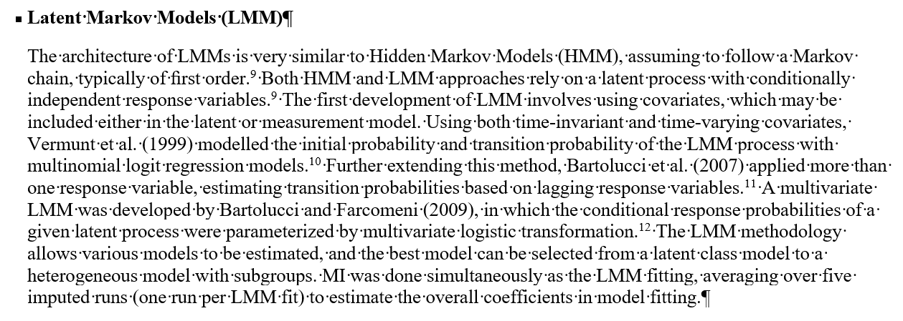

* asdas

# IDENTIFYING CAUSAL MECHANISMS (PRIMARILY) BASED ON INVERSE PROBABILITY WEIGHTING.<https://doi.org/10.1002/jae.2341>

**Timko C, Nash A, Owens MD, Taylor E, Finlay AK. Systematic Review of Criminal and Legal Involvement After Substance Use and Mental Health Treatment Among Veterans: Building Toward Needed Research. Substance Abuse: Research and Treatment. 2020;14. doi:10.1177/1178221819901281**

* In addition, longer treatment was associated with better outcomes among alcohol and drug patients,42,49 and treatment completion (which cannot be achieved if patients are detained or reincarcerated during treatment) was related to a lower likelihood of incarceration than was non-completion.

**VILUGRON, Fabiola; MOLINA G., Temístocles; GRAS-PEREZ, María Eugenia y FONT-MAYOLAS, Sílvia. Precocidad de inicio del consumo de sustancias psicoactivas y su relación con otros comportamientos de riesgo para la salud en adolescentes chilenos. Rev. méd. Chile [online]. 2022, vol.150, n.5 [citado 2023-03-09], pp.584-596. Disponible en: <http://www.scielo.cl/scielo.php?script=sci_arttext&pid=S0034-98872022000500584&lng=es&nrm=iso>. ISSN 0034-9887. http://dx.doi.org/10.4067/s0034-98872022000500584.**

e la razón entre adolescentes que reportan a: consumo de sustancias psicoactivas en el último mes, b: conductas suicidas, c: comportamientos sexuales de riesgo y d: hábitos alimentarios no saludables versus los que no, es significativamente mayor en adolescentes con policonsumo precoz de tres sustancias para: a: tabaco (OR: 78,00; 95% IC: 23,92-254,36); marihuana (OR: 68,95; 95% IC: 26,61-178,67); alcohol (OR: 39,11; 95% IC: 18,79-81,40), b: ideación suicida (OR: 2,59; 95% IC: 1,53-4,39); intento de suicidio (OR: 2,37; 95% IC: 1,35-4,15); planificación suicida (OR: 2,36; 95% IC: 1,36-4,09): actividad sexual (OR: 9,87; 95% IC: 5,83-16,70), c: actividad sexual temprana (OR: 8,67; 95% IC: 5,23-14,39); uso infrecuente de preservativo (OR: 5,19; 95% IC: 2,84-9,49), d: bajo consumo de frutas y verduras (OR: 2,65; 95% IC: 1,38-5,09) y consumo infrecuente de desayuno (OR: 2,23; 95% IC:1,44-3,45), comparado con aquellos sin policonsumo precoz de sustancias. Además, la razón entre adolescentes que reportan episodio de consumo intenso de alcohol, consumo diario de tabaco y consumo diario de marihuana versus los que no, es significativamente mayor en adolescentes con policonsumo precoz de tres sustancias (OR: 7,41; 95% IC: 2,57-21,39; OR: 15,71; 95% IC: 2,07-118,99 y OR: 8,29; 95% IC: 2,45-28,07 respectivamente), comparado con aquellos con consumo precoz de una sustancia

resumen: risky behavior such as suicidal intentions, sexual riesky behavior poorer food patterns

**Bunting. Polysubstance Use Patterns among Justice-Involved Individuals Who Use Opioids 10.1080/10826084.2020.1795683**

**Bunting.Polysubstance use and re-incarceration in the 12-months after release from jail: a latent transition analysis of rural Appalachian women. https://doi.org/10.1080/00952990.2021.1995402**

**Crummy. One Is Not Enough: Understanding and Modeling Polysubstance Use. 10.3389/fnins.2020.00569**

**Meacham MC, Roesch SC, Strathdee SA, Lindsay S, Gonzalez-Zuniga P, Gaines TL. Latent classes of polydrug and polyroute use and associations with human immunodeficiency virus risk behaviours and overdose among people who inject drugs in Tijuana, Baja California, Mexico. Drug Alcohol Rev. 2018;37(1):128-136. doi:10.1111/dar.12524**

**Shaoling Zhong, Rongqin Yu, Seena Fazel, Drug Use Disorders and Violence: Associations With Individual Drug Categories, Epidemiologic Reviews, Volume 42, Issue 1, 2020, Pages 103–116,** [**https://doi.org/10.1093/epirev/mxaa006**](https://doi.org/10.1093/epirev/mxaa006)

Individuals who engage in polydrug use, or the use of multiple drugs at the same time, were more likely to exhibit violent behavior. This was particularly true for individuals who used both stimulants and opioids. Additionally, the study found that individuals who used multiple drugs were more likely to have a drug use disorder and experience other risk factors for violence, such as childhood trauma and mental health issues. Overall, the findings suggest that polydrug use is a significant risk factor for violence in individuals with drug use disorders.

**Olivari, C. F., Gaete, J., Rodriguez, N., Pizarro, E., Del Villar, P., Calvo, E., & Castillo-Carniglia, A. (2022). Polydrug Use and Co-occurring Substance Use Disorders in a Respondent Driven Sampling of Cocaine Base Paste Users in Santiago, Chile. Journal of psychoactive drugs, 54(4), 348–357.** [**https://doi.org/10.1080/02791072.2021.1976886**](https://doi.org/10.1080/02791072.2021.1976886)

Heavy polydrug use patterns and co-occurring SUDs are frequent among active CBP users in the Metropolitan area of Santiago. Previous studies may have underestimated polysubstance use and SUDs in CBP users

**Overall, CBP users tend to concentrate multiple health and social disadvantages, including a high prevalence of psychiatric comorbidities and co-occurring SUDs, which hamper the effectiveness of many treatment and social integration strategies**

Gjersing, L., & Bretteville-Jensen, A. L. (2018). Patterns of substance use and mortality risk in a cohort of 'hard-to-reach' polysubstance users. Addiction, 113, 729-739. doi: 10.1111/add.14053

Hassan, A. N., & Le Foll, B. (2019). Polydrug use disorders in individuals with opioid use disorder. Drug and Alcohol Dependence, 198, 28-33. doi: 10.1016/j.drugalcdep.2019.01.031

Quek, L.-H., Chan, G. C. K., White, A., Connor, J. P., Baker, P. J., Saunders, J.B., et al. (2013). Concurrent and Simultaneous Polydrug Use: Latent Class Analysis of an Australian Nationally Representative Sample of Young Adults. Frontiers in Public Health, 1, 1-9. doi: 10.3389/fpubh.2013.00061

Wang, L., Min, J. E., Krebs, E., Evans, E., Huang, D., Liu, L., et al. (2017). Polydrug use and its association with drug treatment outcomes among primary heroin, methamphetamine, and cocaine users. International Journal of Drug Policy, 49, 32-40. doi: 10.1016/j.drugpo.2017.07.009

finding higher school drop-out, unemployment, sexual risk behaviors, and antisocial behavior among CBP users than in cocaine powder users. Both CBP and cocaine powder users were predominantly polydrug users.

Santis B, R., Hidalgo C, C. G., Hayden C, V., Anselmo M, E., Rodríguez T, J., Cartajena De La M, F., et al. (2007). Consumo de sustancias y conductas de riesgo en consumidores de pasta base de cocaína y clorhidrato de cocaína no consultantes a servicios de rehabilitación. Revista médica de Chile, 135, 45-53. doi: 10.4067/s0034-98872007000100007

**Chan, G., Connor, J., Hall, W., & Leung, J. (2020). The changing patterns and correlates of population-level polysubstance use in Australian youth: a multi-group latent class analysis of nationally representative samples spanning 12 years. Addiction (Abingdon, England), 115(1), 145–155. https://doi.org/10.1111/add.14761**

TAC and POLY were more likely to be male, from an English-speaking background, have a high level of psychological distress and suboptimal health

At population-level, we found that young people with higher income and lower levels of education were more likely to engage in polysubstance use.

**Bunting AM, Oser C, Staton M, Knudsen H. Polysubstance Use Patterns among Justice-Involved Individuals Who Use Opioids. Subst Use Misuse. 2020;55(13):2165-2174. doi:10.1080/10826084.2020.1795683**

Data from prison and jail substance use programing in the state of Kentucky from 2015–2017 was examined.

Findings indicate the heterogeneity of opioid use among a justice-involved population. More diverse polysubstance patterns may serve as a proxy to identifying individuals with competing physical and mental health needs. Future interventions could be tailored to polysubstance patterns during the period of justice-involvement

**Crummy, E. A., O'Neal, T. J., Baskin, B. M., & Ferguson, S. M. (2020). One Is Not Enough: Understanding and Modeling Polysubstance Use. Frontiers in neuroscience, 14, 569.** [**https://doi.org/10.3389/fnins.2020.00569**](https://doi.org/10.3389/fnins.2020.00569)

drug-dependent individuals report an average use of 3.5 substances, incluiding both simultaneous and sequential polydrug use

**Lalwani, K., Whitehorne-Smith, P., Walcott, G. et al. Prevalence and sociodemographic factors associated with polysubstance use: analysis of a population-based survey in Jamaica. BMC Psychiatry 22, 513 (2022). https://doi.org/10.1186/s12888-022-04160-2**

In Latin America and the Caribbean, there is scant information on polysubstance use.

Polysubstance use can be defined as the use of more than one drug either concurrently or consecutively to amplify or neutralize another drug’s effect

Polysubstance use creates severe medical issues such as overdose, psychiatric co-morbidities such as depression, as well as more risky social behaviours such as promiscuous sexual practices, when compared to single drug users [31,32,33,34,35,36,37]. Furthermore, studies have concluded that the mortality rate is three times higher with polysubstance use versus singular drug use [38, 39].

**Reyes, J., Pérez, C., Colon, H., Hynes, M., Cumsille, F., 2013. Prevalence and Patterns of Polydrug Use in Latin America: Analysis of Population-based Surveys in Six Countries. Review of European Studies. 5 doi: 10.5539/res.v5n1p10.**

Regionally, one study utilizing data collected from six countries in Latin America reported that the overall lifetime rate of polysubstance use is 21%

participants engaged in polysubstance use

Although alcohol, marijuana and tobacco were the most common three-substance combination in Latin America, the prevalence ranged from 0.1% to 1.9% for all six countries

In Chile,

**Andrés Herrera Rodríguez, Rosibel Prieto Silva and Monica Veloza Gomez et al. Policonsumo simultáneo de drogas en estudiantes de facultades de ciencias de la salud/ciencias médicas en siete universidades de cinco países de América Latina y un país del Caribe: implicaciones de género, legales y sociales. Texto contexto - enferm.. 2012. Vol. 21(spe):17-24. DOI: 10.1590/S0104-07072012000500002**

**https://www.scielo.br/j/tce/a/dGqfCTrnMG9pTwLM7BWB3wD/?lang=es**

Risk factors for polyconsumption of drugs were beginning drug consumption before age 15, participation in social parties, low education of parents, dysfunctional family, and economic difficulties. Protective factors were importance of religion/belief in life and participation in sports and artistic activity.

**E:\Mi unidad\Alvacast\Resumen FONDECYT\Study Protocol - Frontiers Public Health_ACC_ags.docx**

Also, there is a massive gap in health and epidemiologic research regarding the use of advanced statistics and computer science. These efforts are critical at a time of integration of information systems worldwide, known as the “big data revolution”(Mooney & Pejaver, 2018). One of the main challenges in public health science nowadays is the use of complex information systems in risk prediction and program evaluation (European Commission, 2016). Ours is an effort to incorporate rigorous methods on the analysis of population-level data, aiming to have a direct public health impact. In this sense, it can be considered as one an example of the potential uses of national information systems to monitor and evaluate national goals. For example, our objectives align with two public health strategies in Chile: (1) the Sanitary Goals for the Decade 2011-2020 (Ministerio de Salud, 2011-2020) and the (2) National Mental Health Plan 2017-2025 (Ministerio de Salud, 2017), and we expect these results can serve as an evaluation tool to inform current and subsequent public health planning.

**Types of criminal legal system exposure and polysubstance use: Prevalence and correlates among U.S. adults in the National Survey on Drug Use and Health, 2015–2019 https://doi.org/10.1016/j.drugalcdep.2022.109511**

- Polysubstance use is generally defined as the use of more than one substance simultaneously or during a defined period-of-time (Connor et al., 2014). Polysubstance use is common among people who use drugs and is associated with drug-use persistence, as well as increased morbidity and mortality (Fedorova et al., 2019, Hedegaard et al., 2020, McCabe et al., 2017, Ford et al., 2021).

- While some characteristics (i.e., age, ethnicity, SUD) were consistently associated with polysubstance use across types of CLS exposure, other characteristics (i.e., sexual identity, marital status, suicidal ideation) were not.

- Dado los altos niveles de comorbilidad entre problemas de salud y SUD (Hartz et al., 2014; Lai et al., 2015), identificar correlatos de salud relacionados a exposición a CLS (criminal legal system) y policonsumo es importante

[**https://www.dipres.gob.cl/597/articles-214465_informe_final.pdf**](https://www.dipres.gob.cl/597/articles-214465_informe_final.pdf)

**Dirección de Presupuestos[DIPRES], Centro de Estudios Justicia y Sociedad Instituto de Sociología UC[ISUC]. Evaluación de resultados de los programas de tratamiento y rehabilitación del Servicio nacional para la prevención y rehabilitación del consumo de drogas y alcohol, SENDA. Centro de Estudios Justicia y Sociedad Instituto de Sociología UC. Santiago, Chile, 2020.  
http://www.dipres.gob.cl/597/w3-article-214465.html. Accessed March 03, 2021.**

Gráfico 15: Policonsumo, abuso (DSM-IV) y abstemio año en T0, T1 y T2 (N=371)

En relación a las variables de consumo, vemos que en general hubo dificultades en volver a contactar a

las personas policonsumidoras con sustancia principal la pasta base (42,8%), y se logró contactar en menor medida personas con compromiso delictual en comparación a quienes no lo presentaban (seguimiento post-egreso).

**Evans EA, Zhu Y, Yoo C, Huang D, Hser YI. Criminal justice outcomes over 5 years after randomization to buprenorphine-naloxone or methadone treatment for opioid use disorder. Addiction. 2019;114(8):1396-1404. doi:10.1111/add.14620**

Experiences of treatment and incarceration during follow-up were provided by self-reported TLFB data, which have been determined to provide adequate reliability and validity,(20, 40, 41) but nevertheless may be subject to recall bias. Additionally, exposure to incarcerated settings increases the likelihood of severe health limitations (26) and it is associated with greater disparities in health conditions. (27) Unlike in several European countries and elsewhere, where pharmacotherapy to treat opioid use disorder is offered to prisoners during and after incarceration, (28–31) incarceration in the U.S. has historically been associated with an interruption of such pharmacotherapy, (Timeline Follow-Back (TLFB)

Specific-baseline hazard models assume thatthe exact number of previous episodes suffered by each subject is known, but in reality it is typically impractical to obtain an exhaustive history for each patient. This leaves us without a method to directly address event dependence. The usual practice in such cases is to fit models with a common-baseline hazard.

**Font-Mayolas, S., & Calvo, F. (2022). Polydrug Definition and Assessment: The State of the Art. International journal of environmental research and public health, 19(20), 13542.** [**https://doi.org/10.3390/ijerph192013542**](https://doi.org/10.3390/ijerph192013542)

The definition of polydrug use has varied since its inception, and consequently, so have forms of self-report evaluation. WHO: the consumption of more than one kind of drug by an individual.

Berglund, 2012  
**Håkansson, A., Berglund, M. Risk factors for criminal recidivism – a prospective follow-up study in prisoners with substance abuse. *BMC Psychiatry* 12, 111 (2012). https://doi.org/10.1186/1471-244X-12-111**

*Even when controlling for type and severity of crime, and for psychiatric problems, risk of criminal relapse was increased by substance use variables, including amphetamine, heroin and polysubstance use, and an additional risk was shown for injection drug users. These findings have implications for the need for substance abuse treatment after release from prison.*

**Carbonneau, R., Vitaro, F., Brendgen, M., & Tremblay, R. E. (2023). Longitudinal patterns of polysubstance use throughout adolescence: association with adult substance use and psychosocial outcomes controlling for preadolescent risk factors in a male cohort. *Social psychiatry and psychiatric epidemiology*, 10.1007/s00127-023-02454-8. Advance online publication. https://doi.org/10.1007/s00127-023-02454-8**

Adolescent PSU contributed to both age-24 substance-related outcomes (frequency of alcohol, drug use, and getting drunk, risky behaviors under influence, and use-related problems) and psychosocial outcomes (no high school diploma, professional or financial strain, ASP symptoms, criminal record) over and above preadolescent risk factors.

**Bunting, A. M., Dickson, M., & Staton, M. (2022). Polysubstance use and re-incarceration in the 12-months after release from jail: a latent transition analysis of rural Appalachian women. *The American journal of drug and alcohol abuse*, *48*(3), 356–366. https://doi.org/10.1080/00952990.2021.1995402**

Women who were re-incarcerated during follow-up were likely to remain engaged in, or transition to, the *High Polysubstance/IDU* class (ORs: 3.14-46.56).

**Lammers, S. M., Soe-Agnie, S. E., de Haan, H. A., Bakkum, G. A., Pomp, E. R., & Nijman, H. J. (2014). Middelengebruik en criminaliteit: een overzicht [Substance use and criminality: a review]. *Tijdschrift voor psychiatrie*, *56*(1), 32–39.**

Substance abuse, particularly the combination of alcohol and drugs, is a predictor of criminality and criminal recidivism.

**Beaudoin, M., Potvin, S., Dellazizzo, L., Luigi, M., Giguère, C. E., & Dumais, A. (2019). Trajectories of Dynamic Risk Factors as Predictors of Violence and Criminality in Patients Discharged From Mental Health Services: A Longitudinal Study Using Growth Mixture Modeling. *Frontiers in psychiatry*, *10*, 301. https://doi.org/10.3389/fpsyt.2019.00301**

The final model to predict high criminality yielded an AUC of 0.788, retaining as predictors male sex, lower educational level, higher score of psychopathy (baseline), persistent polysubstance use (cannabis, cocaine, and alcohol), and persistent cannabis use (alone).

**Vergunst, F., Chadi, N., Orri, M., Brousseau-Paradis, C., Castellanos-Ryan, N., Séguin, J. R., Vitaro, F., Nagin, D., Tremblay, R. E., & Côté, S. M. (2022). Trajectories of adolescent poly-substance use and their long-term social and economic outcomes for males from low-income backgrounds. *European child & adolescent psychiatry*, *31*(11), 1729–1738. https://doi.org/10.1007/s00787-021-01810-w**

Four poly-substance use profiles were identified: abstinent (n = 128, 14.4%), late-onset (n = 412, 46.5%), mid-onset (n = 249, 28.1%), and early-onset (n = 98, 11.1%). Relative to the late-onset (reference) group, participants in the early-onset profile were 3.0 times (95%CI = 1.68-5.53) more likely to have left school without a diploma, 2.7 times (95% CI = 1.56-4.68) more likely to have a criminal conviction by age 24 years, earned 10,185 USD less (95% CI = - 15,225- - 5144) per year at age 33-37 years and had 15,790 USD lower (95% CI = - 23,378- - 8218) household income at age 33-37 years, a 1.3 times (95%CI = 1.15-1.57) higher incidence of annual welfare receipt and a 24% (95% CI = 5-40) lower incidence of marriage/cohabitation from age 18-35 years. We show that adolescent-onset poly-substance use by age 13 is associated with poor social and economic outcomes.

**Andersson HW, Lauvsnes ADF, Nordfjærn T. Emerging Adults in Inpatient Substance Use Treatment: A Prospective Cohort Study of Patient Characteristics and Treatment Outcomes. *Eur Addict Res*. 2021;27(3):206-215. doi:10.1159/000512156**

Multivariable results showed that polysubstance use and an attention deficit hyperactivity disorder (ADHD) diagnosis were the strongest predictors of unfavorable treatment outcomes for emerging adults.

**Franklyn AM, Eibl JK, Gauthier GJ, Marsh DC. The impact of cannabis use on patients enrolled in opioid agonist therapy in Ontario, Canada. *PLoS One*. 2017;12(11):e0187633. Published 2017 Nov 8. doi:10.1371/journal.pone.0187633**

A retrospective chart review study (N=503) of patients undergoing compulsory treatment for heroin in China also found that men experienced higher rates of “negative treatment outcomes” (defined as incarceration, treatment readmission) than women when they endorsed polysubstance use at treatment entry[39](https://www.ncbi.nlm.nih.gov/pmc/articles/PMC6591072/#R39).

highlights the importance of programs focusing on substance abuse disorders generally, not just risk factors associated with individual substances

**Tan, H., Liang, D., Zhong, N., Zhao, Y., Chen, Z., Zhao, M., & Jiang, H. (2019). History of Alcohol and Opioid Use Impacts on the Long-Term Recovery Trajectories of Methamphetamine-Dependent Patients. Frontiers in psychiatry, 10, 398. https://doi.org/10.3389/fpsyt.2019.00398**

**Levola, J., Aranko, A., & Pitkänen, T. (2021). Psychosocial difficulties and treatment retention in inpatient detoxification programmes. *Nordic Studies on Alcohol and Drugs*. https://doi.org/10.1177/14550725211021263**

Younger individuals with opioid and/or polysubstance use were less likely to complete detoxification treatment than older individuals with alcohol as their primary substance.

**Andersson HW, Lauvsnes ADF, Nordfjærn T. Emerging Adults in Inpatient Substance Use Treatment: A Prospective Cohort Study of Patient Characteristics and Treatment Outcomes. Eur Addict Res. 2021;27(3):206-215. doi:10.1159/000512156**

Polysubstance use and ADHD were important predictors of unfavorable outcome among emerging adults. For adults, mental distress was the only baseline predictor of treatment outcome.

**Choi, N. G., & DiNitto, D. M. (2020). Older-Adult Marijuana Users in Substance Use Treatment: Characteristics Associated with Treatment Completion. Journal of Psychoactive Drugs, 1–10. doi:10.1080/02791072.2020.1745966**

whereas all marijuanainvolved polysubstance cases had lower odds of completing outpatient treatment (partially supporting H1

**Basu D, Ghosh A, Sarkar S, Patra BN, Subodh BN, Mattoo SK. Initial treatment dropout in patients with substance use disorders attending a tertiary care de-addiction centre in north India. Indian J Med Res. 2017;146(Supplement):S77-S84. doi:10.4103/ijmr.IJMR_1309_15**

An interesting finding of the current study was the inverse association of polysubstance use and treatment attrition. The speculative reason could be higher clinician's involvement and attention in those with more than two substance use disorders. Many of earlier studies were on patients who were on agonist maintenance programme for opioid dependence, while the patients in our study represented a heterogeneous mix of substance users.

**Körkel, J. (2021), "Treating patients with multiple substance use in accordance with their personal treatment goals: a new paradigm for addiction treatment", Drugs and Alcohol Today, Vol. 21 No. 1, pp. 15-30. https://doi.org/10.1108/DAT-10-2020-0065**

**MM**: Chile es un ejemplo de tratamientos orientados a multi-sustancias o que de alguna manera permite trabajar con policonsumo(que no es el caso de paises ricos, en gral)

# Fuentes (mediación)

* As discussed in Robins and Greenland (1992), random treatment assignment does not imply exogeneity of the mediator. Therefore, the total effect cannot be disentangled by simply conditioning on a mediator, because this generally introduces selection bias coming from variables influencing both the mediator and the outcome, see Rosenbaum (1984)

## Causal mediation analysis example

<https://static1.squarespace.com/static/64c0cf7f4c378921020036e6/t/64c54d8d9da8b452a495f3f2/1690652045563/sizarakolobufuj.pdf>

* el análisis de mediación examina el proceso intermedio en que la variable independiente afect ala dependiente.
* cutting-edge counterfactual framework y técnica de montecarlo para conducir el análisis de mediación. Permite hasta 3 mediadores: numérico, dicotomizado y de recuento y variables dependientes, datos perdidos usando imputación múltiple.
* El análisis de mediación fue realizado basado en el marco contrafactual y el efecto de la intervención (Vansteelandt and Daniel, 2017; Chan and Leung, 2020).
  + Chan G, Leung J. Causal mediation analysis using the interventional effect approach. A refined definition. Paper under review. 2020.
* in other words, how the intervention influences the outcome through a mediator
* Mediation analysis (Baron and Kenny, 1986; MacKinnon, 2008) is routinely applied to investigate mediation effects. Recently, causal mediation analysis (Robins and Greenland, 1992; Pearl, 2001; Robins, 2003; Imai et al., 2010a,b, 2011; Imai and Yamamoto, 2013; VanderWeele, 2015) has been proposed and provides a new perspective to understanding mediation. Conventional mediation analysis and causal mediation analysis are not completely different in terms of modeling perspectives. However, based on the potential outcomes framework (Holland, 1986), causal mediation analysis provides methods to evaluate the assumptions required in establishing the causal role of a mediator, which may not be the case with conventional analysis. Causal mediation analysis does so by clearly identifying and evaluating required assumptions through sensitivity analysis that supplies measures of how robust results are to violations of the assumptions needed to establish causality. In addition, causal mediation analysis introduces a more general definition of the causal mediation effect. The approach provides non-parametric definitions of causal mediation effects and allows accommodating various types of models (linear and nonlinear), mediators (continuous and discrete), and outcome variables (continuous and discrete). Based on non-parametric definitions, causal mediation effects can be estimated through various parametric and non-parametric estimation methods. Despite these advantages and the availability of various software programs (Valente et al., 2020), causal mediation analysis does not appear to be employed as much as conventional mediation analysis in experimental designs found in educational studies (Imai et al., 2010a; Cuartas and McCoy, 2021). The insufficient use of causal mediation methods is notable considering the more recent focus on experimental and quasiexperimental methods to evaluate causal effects (Hufstedler et al., 2021; Yeboah et al., 2021). The current What Works Clearinghouse (WWC) standards for effectiveness studies do not yet include guidance on causal mediation methods (What Works Clearinghouse, 2020). To encourage the use of causal inference in applied studies, in this paper, we provide practical guidance for applied researchers. We provide a step-by-step explanation of causal mediation analysis with an accessible example. Through this guide, we aim to promote and foster more use of causal mediation analysis in applied educational research. The remainder of this paper is structured as follows: “A Running Example” presents our empirical example of an RCT design in education
* El análisis de mediación se aplica rutinariamente para investigar los efectos de mediación (Baron and Kenny, 1986; MacKinnon, 2008). Recientemente, el análisis de mediación causal se ha propuesto provee una nueva perspectiva para entender mediación. El análisis convencional y el causal no son completamente distintos en términos de perspectivas de mdelación. Sin embargo, en el marco de los resultados potenciales, el análisis de mediación causal proporciona métodos para evaluar los supuestos requeridos para establecer el rol causal del mediador, que puede que nos ea en el caso del análisis convencional. El análisis de mediación causal lo hace al identificar claramente y evaluar los supuestos requeridos a través de análisis de sensibilidad que dan medidas para ver cuán robustas son los resultados a violaciones de los supuestos para establecer causalidad.
* La aproximación, dado que es no-paramétrica, pueden ser estimadas a través de métodos de estimación paramétricos y no-paramétricos.
* Permite acomodar varios tipos de modelos (lineales y no-lineales), mediadores (continuos y discretos) y variables de resultados (continuas y discretas). Basado en definiciones no-paramétricas, los efectos de mediación pueden usarse a través de distintos tipos de esimación. A pesar de estas ventajas y la dispnibiliad de varios software, el análisis de mediación causal no

## Lee H, Cashin AG, Lamb SE, et al. A Guideline for Reporting Mediation Analyses of Randomized Trials and Observational Studies: The AGReMA Statement. JAMA. 2021;326(11):1045–1056. doi:10.1001/jama.2021.14075

* Qué información reportar en análisis de mediacion de ensayos clínicos y observacionales

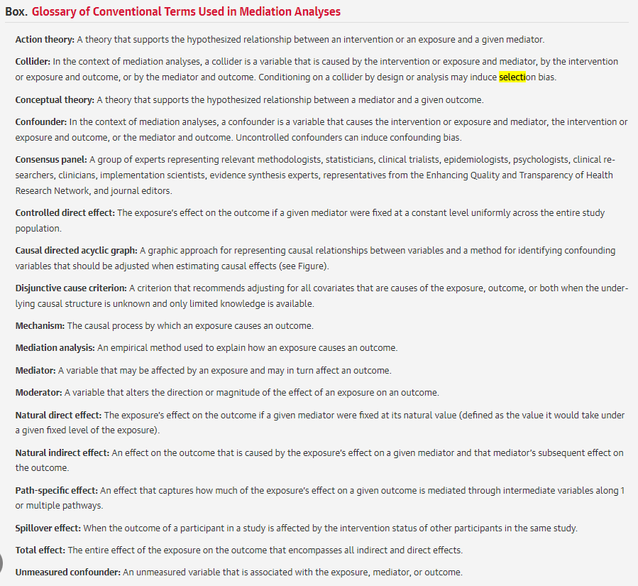

* **Título**: incluir que s ehace análisis de mediación, mediation, mediator o mediation analysis en keywords
* **Abstract**: describir los objetvos del estudio, con una nbreve declaración del trasfondo y racionalidad detrás de los mecnaismos de interés, métodos (configuración, participantes, tamaño muestra, exposición, mediador, resultado y estrategia analítica de mediación, resultados (con intervalos de confianza) y conclusión principal
* **Introducción**: dar contexto de la materia de estudio y la configuración clínicca del estudio. El ana´lisis de mediación será usado apra entender los mecnismos por los que una intervención o exposición puede afectar n resultado. Describir por qué el análisis de mediación da respuesta a preguntas científicas sustanciales. Describir la teoría que **subyace o apunta el mecanismo propuesto de interés** indicando por qué la exposición o intervención se espera afecte el mediador propuesto (teoría de acción), y por qué el mediador se espera afecte el resultado (teoría conceptual). Esta lógica debiese reflejar cada objetivo.
* **Objetivo**: determinar si hay la presencia de un efecto indirecto o directo, estimar la magnitud del efecto indirecto. O también pueden indicar si explicativo (para explicar qué media una relación causal) o intervencional (para preguntarse sobre el mecanismo causal posibla o hipotético que apunta la exposición o mediador. Cuando se usan para esto, los autores deben indicar los objetivos pero destacar que el objetivo del análisis de mediación es secundario
* **Métodos**: Si es posible, referenciar protocolos o pre-registros o indicar desviaciones de un protocolo. Si el estudio no está registrado o vinculado a un protocolo, los autores deben declarar explícitamente la naturaleza exploratoria del análisis de mediación.
  + Diseño del estudio y fuente de datos: randomized trial o observacionales (cohorte o caso-control); que el estudio detalle características del diseño, referenciando publiacaciones detalladas del estudio original que origina los datos. Cuando no se puede, hay que detallar mejor las fuentes de datos y el diseño. Los diferentes diseños requieren distintos supuestos. Permitirá ver las distintas fuentes potenciales de sesgo.
  + Participantes: población objetivo; representatividad, eligibildiad y reclutamiento, donde y cuándo se llevó a cabo. Servirá para la generalizabilidad y la heterogeneidad.
  + Tamaño de la muestra: son difíciles en este diseño, pero si se hizo, reportar el método de cálculo y los estimadores usados en cálculo (eg, the effect of the exposure on the mediator and residual mediator variance, the effects of the exposure and the mediator on the outcome and residual outcome variance, significance level, and desired power)
  + Efectos de interés: Se apunta a estimar uno o más de los siguientes efectos posibles: exposición-mediador, mediador-resultado, efecto directo controlado, natural directo e indirecto, intervencional directo e indirecto, path-specific. Como el efecto elegido requerirá un set de supuestos, el método analítico y la interpretación, es escencial reportar claramente el efecto hipotetizado para que sea más relevante a los objetivos de estudio. En algunas instancias, los investigadores tendrán muchos, por lo que se recomeinda vincularlos a los objetivos
  + Modelo causal supuesto: incluir una representación gráfica del supuesto causal, se recomeinda DAG, incluir variables medidas y no medidas, ver si hay collider (condicionar en uno)
  + Supuestos causales: supuestos causales, fuentes posibles de sesgo, hasta que medida se puede interpretar la asociación como una relación causal, indicar la precedencia temporal, posibilidad de reverse causation, supuestos de modificación del efecto, positividad, consistencia
  + Medida: definir las variables, cómo se midieron y el instrumento, especificar el principio del seguimiento, criterios de elegibildiad o cuando inicia la exposición o intervención,
  + Niveles de medición: Si es relevante, decir a qué niveles se midieron la exposición, mediador y resultado. Hay veces que los individuos están agrupados por cluster. Ver cómo se midieron o asignaron en el nivel grupal e individual.
  + Métodos estadísticos: Dos tradiciones: pasos causales de Baron & Kenny o marco de producto y diferencia de coeficientes, y aquellos del marco contrafactual. Indicar cuál de los marcos se utilzaron. Especificar los métodos utilizados. Nombre y versión del software.
    - Análisis de mediación usan una aproximación dirigida por la teoría para ajustar confusores de los caminos. Cómo los confusores se identifican por DAG, disjuntive cause cvriterion, o si es dirigdo por datos, por stepwise o penalización. Las mediaciones usan regresiones,
  + Análisis de sensibilidad: Influencia de datos perdidos, supuestos causales o estadísticos Los supuestos causales que subyacen al modelo investigado, por ejemplo, suponiendo que no hay confusión residual en las vías causales o la dirección (ej., entre múltiples mediadores), o la ausencia de causas comues para múltiples mediadores. Mediational e-value. Si bien los modelos causales no pueden ser veríficados, los supuestos estadísticos sí. Residual plots, pruebas de bondad de ajuste, métodos de imputación y manejo de datos perdidos.
  + Ética:Se espera aprobación de un institutional research board o ethics committee.
* **Resultados**:
  + participantes: características a la base de la muestra (demográficos, características clínicas, mediador y resultado), tamaño de la muestra total y partiipantes perdidos en el seguimiento, posibles confusores por pérdidas de seguimiento, sentido del sesgo de selección. Reportar la submuestra incluida en el análissi de mediación , de haber una particular. Reportar el efecto total sin considerar el mediador.
  + resultados y estimadores: Dependerá de los objetivos del estudio, se recomienda que el efecto directo natural y e indirecto. Si el objetivo del estudio es estimar la relación causal entre exposición y un resultado mientras un mediador es fijado a un nivel constante, el efecto directo controlado es recomendado: causal relationship between an exposure and an outcome while a mediator is fixed at a constant level uniformly across the population
    - estimación de las relaciones exposición-mediador y mediador-resultado requieren supuestos más débiles que la estimación de efectos directos e indicrectos, por lo que deen darse explicaciones de posibles mecanismos de interés
    - utilizar estimaciones estandarizadas, no-estandarizadas, 95% CIs
    - escalas de medición: mean difference, risk difference
  + Otros autores puede elegir reportar la proporción mediada (o eliminada) con el 95% Ci como un resultado descriptivo de los resultados. Dado que hay mucha incertidumbre en la proporción mediada, especialmente en muestras pequeñas, se recomienda poner foco en el efecto directo e indirecto
  + Parámetros de sensibilidad: Reportar lso resultados como mediational e-value o confusor residual, ser claro de la métrica usada y dar una interpretación breve
* **Discusión**: Limitaciones y posibles fuentes de sesgo, como confusores no-medidos, error de medida, mala especificación del modelo, sesgo de selección y datos perdidos. Si algun analisis de sensibilidad hace un análisis, se reporta la limitación La interpretación de los efectos considerando magnitud e incertidumbre (hallazgos principales deben ser poco), plausibilidad de llos supuestos causales, limitaciones, generalizabilidad de los resultados y resultados de otros estudios. Los resultados principales en función de los objetivos deben ser sintetizados en un párrafo corto. Dependerá de cuán razonable son los supuestos causales y complementarios de sensibilidades. La interpretación debe estar en el contexto de la literatura, si los resultados desafían o añaden a la teoría. Finalmente, las implicaciones deben dar luz si influencian la práctica clínica, políticas o futuras investigaciones. Por ejemplo, sugerir cómo una intervención o política puede ser entregada a (o a evitar) un mediador específico
* **Otros**: rol de patrocinador, conflictos de interés y financial discolusres, se promueve que s ehaga una declaración para compartir datos y código, como mínimo, hacer un statement.

## asdasd

* El análisis de mediación causal introduce una definición más general paa el efecto de mediación causal. Identifica y evalua los supuestos requeridos a través de análisis de sensibilidad para dar medidas de cuán robstos son los resultados a violaciones de los supuestos para establecer causalidad.
* El problema del análisis de mediación convencional, es que no garantiza una conclusión sobre el rol causal del mediador. Los confusores potenciales no se consideran, por lo que los resultados podrían estar sobreinterpretando (upward bias).
  + Primero ver si las muestras de comparación están balanceadas, también en términos de atrición (llegar a M)
  + Es prudente examinar cómo confusores pre o post-tratamiento no medidos podrían impactar las estimaciones del efecto mediador. Estos podrían confudir la relación entre el mediador y el resultado. El supuesto de pre y post confusores son cruciales para una inferencia válida, pero no son testeables.
  + No hay interacción entre el focal y el tratamiento; pero a veces este supuesto no se sostiene, porque el rol de mediador puede ser distinto en el control y en el tratamiento.
* **Análisis de mediación causal: el efecto de mediación causal para el paciente i captura la diferencia entre el resultado observado del participante y el contrafactual si el estatus del participante en tratamiento se mantiene, pero el valor del mediador iguala al valor bajo el otro estatus de tratamiento.**

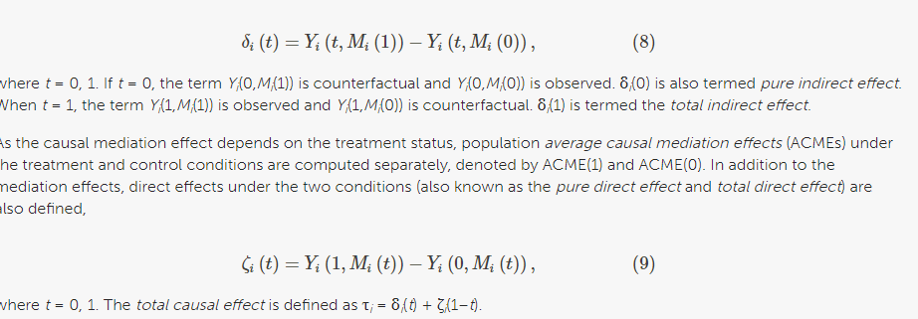

* Si t= 0, el término Yi(0,Mi(1)) es contrafactual y el Yi(0 Mi(0)) es observado. Ese δ*i*(0) se define como el efecto indirecto puro. Cuando t=1, el término Yi(1,Mi(1)) es el observado y el Yi(1,Mi(0)) es el contrafactual. δ*i*(1) es el efecto indirecto total.
* Dado que el efecto de mediación causal depende del estatus de tratamiento, el efecto poblacional promedio de mediación (average causal mediation effect ACMEs) bajo tratamiento y control se computan sepaadamente, (ACME 1 y ACME 0)
* Adicional al efecto de mediación, los efectos directos bajo ambas condiciones: el efecto directo puro y el efecto directo total también se obtienen:

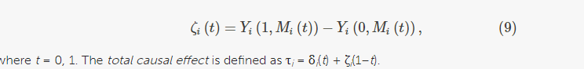

* + asd

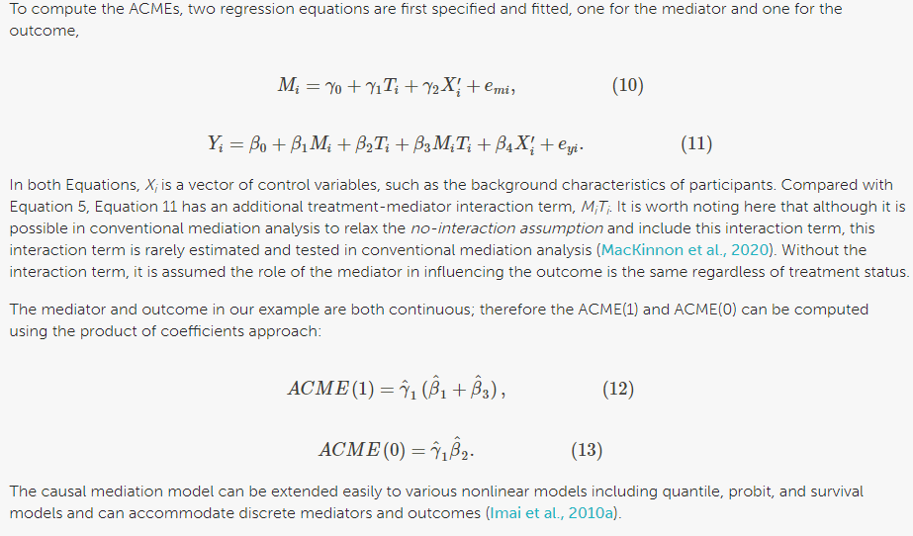

* Análisis de sensibilidad:
  + para identificar los estimadores obtenidos mediante análisis de mediación causal, se asume que no hay confusores no medidos ni confusores post-tratamiento. Aunque esos supuestos no son testeables. Una ventaja del análisis de mediación causal es que permite examinar cuán sensible los ACMEs son a violaciones postenciales de tales supuestos. En el análisis de mediación causal, el grado de violación posible de confusores pre tratamiento no medidos puede cuantificarse en una medida que se basa en la correlación entre los residuos de la regresión:
    - ρ=corr(emi, eyi).(16)
  + Cuando no hay confusores no medidos pre-tratamiento hay un p=0, mientras que cuando p es grande hay un confusor fuerte entre el mediador y el resultado. También podemos fijar p y reestimar el ACME para encontrar el valor de p en el que ACME es 0. Este representa el valor de confusor necesario para resultar en no ACME. Mientras mayor, más robusto es el ACME
  + Cuando hay multiples mediadores, esa medida es la sensibilidad al supuesto de interacción homogénea (el efecto de la interacción de tratamiento-mediación en el resultado es el mismo a través de unidades), el que si es violado indica sesgo en la estimación del efecto del mediador en el resultado a través de la interacción. standard deviation of the coefficient β3 i
  + <https://www.frontiersin.org/articles/10.3389/feduc.2022.886722/full>
  + <https://www.publichealth.columbia.edu/research/population-health-methods/causal-mediation>
  + <https://www.mdpi.com/2071-1050/15/6/4929>
  + <https://www.waseda.jp/inst/wias/assets/uploads/2022/03/RB014_041-053.pdf> --> analytic strategy
  + <https://ipsr.ku.edu/new/Tingley_Presentation040513.pdf>
* Se recmienda un procedimiento de 4 pasos:

## Testing Mediation with Regression Analysis

<https://web.pdx.edu/~newsomj/semclass/ho_mediation.pdf>

* Aproximasción clásica de Baron y Kenny (1986), 4 pasos: regresión sola de X --> Y; X --> M; ; M --> Y; X --> M --> Y
* 1-3, establecen una relación de orden 0 entre las variables. Si una o más de esas relaciones no es significativa, los investigadores concluyen que la mediació nno es posibl, aunque no siempre es verdad. Asumir que hay relaciones significativas entre 1-3, uno procede al 4.
* En el 4, uno hace unaa forma de mediación apoyada por el efecto de M (path ) que se mantiene significativa, después de controlar por X. Si X no es significativa cuando se controla por M, el hallazgo apoya la mediación completa; si no, hay una mediación parcial.

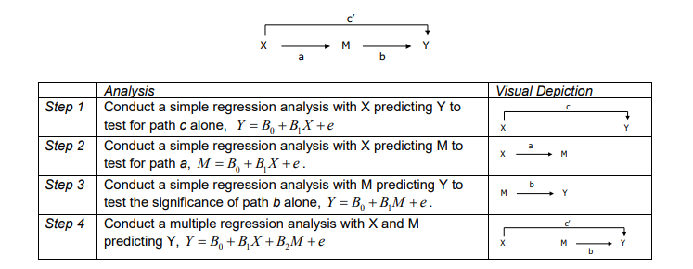

* **Calculando el efecto indirecto**: Aunque hay problemas con este cálculo, es que uno nunca realmente prueba la significancia de la vía indirecta (X --> Y por a y b). Otro problema es que se pierden efectos de mediación verdaderos (errores tipo 2). Una alternativa es calcular el efecto indirecto y probarlo para significancia. El coeficiente de regresión para el efecto indirecto representa el cambio de Y por cada unidad de cambio de X que es mediada por M.
* Aproximación recomendada para aproximar el test de significancia del efecto indirecto: nonparametric resampling (bootstrap) y monte carlo (llamado parametric resampling o numerical integration).
  + Bootstrap: intervalos de confianza usando puntos de corte de la distribución de muestreo sin explicitar correcciones al sesgo; el otro es el bootstrap que corrige por el sesgo, en el coeficiente indirecto utilizando la estimación promedio de las muestras bootstrap.
  + Montecarlo: implica cmputar el efecto indirecto y el error estandar de los coeficientes para la muestra completa.
* Recomedada: el bootstrap corregido por sesgo resulta en errores de tipo 1 mayores que el de percentil, el cual es mayor cuando el tamaño de la muestra es mayor, los senderos son pequeños o el a o b son cercanos a 0. Dicen que montecarlo o percentil se desempeña mejor en error tipo 1. Tiene mayor poder estadístico el corregido po r sesgo, pero al costo de error tipo 1 inflado.
* asdsa

## Supplemental Content (SC) Multiple mediators approach to study environmental determinants of health disparities

* We first used mediation analysis to determine the proportion of the X-Y disparity that is mediated by E, without taking B into account.
* explaining racial/ethnic disparities (X) in cardiovascular disease (CVD) risk (Y).
* This result shows that by ignoring exposure-mediator interaction when this was truly present, we under-estimated the contribution of the mediator in the association of interest.
* Confounding assumptions within the counterfactual framework
  + causal mediation effects
  + Al poner el análisis de mediación en el marco contrafactual de la inferencia causal, uno puede definir efectos de mediación causal (i.e. controlled direct effect – CDE; natural indirect effect - NIE) de manera que no queden vinculados a un modelo estadístico específico e identificarlos mediante 4 supuestos:
    - no hay confusores no medidos entre la asociación exposición-resultado
    - no hay confusores no medidos sobre la asociación mediador-resultado
    - no hay confusores no medidos entre la asociación exposición-mediador
    - no hay un efecto de la exposición en un confusor de la relación entre mediador y resultado.
  + Sólo los supuestos 1 y 2 son los requeridos para identificar el efecto controlado directo y por tanto la medida de disparidad étnica/racial
  + Ahora bien, puede que los supuestos sobre confusores no medidos no se sostengan. En particular, los estudios clínicos y observacionales tienden a diseñarse para evaluar asociaciones exposición-resultado y recolectar o aleatorizar una variedad de posibles confusores de esta asociación. Sin embargo, para identificar correctamente los efectos directos e indirectos, es necesario **controlar por confusores de la asociación mediación-resultado**. La presencia de confusores residuales de esta asociación pueden limitar la interpretación del análisis de mediación. Para hacer inferencia robusta de los settings evaluados, es necesario realizar análisis de sensibilidad. Mucho de la investigación de análisis de mediación causal se ha enfocado en desarrollar técnicas de análisis de sensibilidad para evaluar cómo las conclusiones pueden ser alteradas al violar los supuestos requeridos.
* Extensiones del análisis de mediación
  + No-linealidad: permite distribuciones no lineales del mediador y el resultado
  + Medidas repetidas: Este método permite ver exposición, mediación o resultados tiempo-dependientes. EL método usa la fórmula de mediación para formalizar efectos directos e indirectos en el contexto de datos longitudinales pero permitiendo la interacción exposición-mediador. Aunque este no ha sido extendido para incorporar la presencia de múltiples mediadores.

## Burgos Ochoa, L, Rijnhart, JJM, Penninx, BW, Wardenaar, KJ, Twisk, JWR, Heymans, MW. Performance of methods to conduct mediation analysis with time-to-event outcomes. Statistica Neerlandica. 2020; 74: 72–91. https://doi.org/10.1111/stan.12191

* Mediación: busca identificar hasta qué punto la asociación exposición-respuesta puede ser explicada por un mediador.
* No se recomienda Cox porque sólo funciona bien en caso de resultados raros. En cox no dan lo mismos valores: product (a[XM]b[MY]) y difference (c[efecto xy no mediación]-c [efecto xy con mediación]’) methods,
* Potential outcomes: pueden estimarse de distintas maneras, como simualciones, integración numérica, modelos de regresión. El marco de resultados potenciales puede ser utilizado para muchas variables incluso las tiempo dependientes. tanto cox como AFT, aunque hay poco conocimiento de su desempeño.
  + Efecto natural indirecto (NIE): la diferencia entre un resulto de tiempo al evento al cambiar el valor del mediador
  + Efecto natural directo (NDE): la diferencia entre un resultado de tiempo al evento al cambiar el valor de la exposición
  + El efecto total es la suma de ambos
  + Vansteelandt et al. (2012) and Lange hacen un método de simulación para estimar los 4 resultados potenciales (asumiendo binario) que se requieren. 5 pasos:
    - 1. datos originales para imputar: resultado ~ exposición + mediador
    - 2. base de datos en que todas las observaciones estén dos veces: x (original) y x* (potencial, opuesto a lo observado)
    - 3. imputar el resultado potencial a Y(x, M(x*)) como el valor observado del resultado de las observaciones de la base de datos donde x = x*, y el resultado predicho basado en el modelo de imputación
    - 4. la del paso 3 es la dependiente, y x y x* se crearon en paso 2 son las independientes. Aquí: x= NDE y x*= NIE
    - 5. Repetir el proceso 10 veces y combinar el resultado de esas 10 imputaciones en un NIE y NDE mediante imputación múltiple.
  + Both traditional mediation analysis and the potential outcomes framework based on the Cox PH model obtained estimates with a higher MSE than the AFT-based estimates. Only in two scenarios, the Cox PH model approximated the corresponding underlying indirect effect, when estimating ab based on traditional mediation analysis in scenarios with constant hazards, and when estimating the NIE on the potential outcomes framework in scenarios with rare outcomes and constant hazards.
  + AFT model with the Weibull distribution yielded more precise estimates (lower MSE and SE) than those based on the Cox model. However, this gain in precision comes at a price: the AFT being a parametric model poses more assumptions than the Cox model, and the violation of the Weibull assumption will result in biased estimates.

**Lange, T., Hansen, K. W., Sørensen, R., & Galatius, S. (2017). Applied mediation analyses: A review and tutorial. Epidemiology and Health, 39. https://www.e-epih.org/upload/pdf/epih-39-e2017035.pdf**

* Sirve para buscar los mecanismos de X e Y.
* Luis Pasteur, contaminación --> bacteria ---> enfermedad
* tratamiento inveasivo --> infarto tr. invasivo ---> terapia preventiva ---> infarto

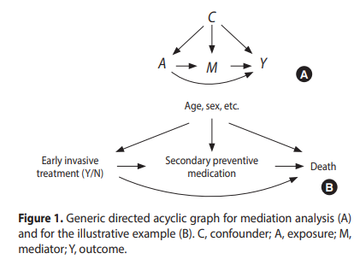

* El efecto natural indirecto es el efecto que se vería al cambiar el mediador, como si uno hubiera cambiado el tratamiento sin cambiar el tratamiento por sí mismo. De la misma forma, el efecto natural directo es el que uno vería si cambiara el tratamiento, pero manteniendo el mediador fijo en cualquier nivel fuera si no se hubiera cambiado el tratamiento. Por tanto, al introducir el contrafactual anidado E[Y (a, M (a*))] para a ≠ a* podemos dar una definición matemática precisa de mediación.
* Esta definición la introdujo originalmente Pearl y muchos trabajos se han hecho de identificación, estimación y aplicación, terminando en un libro de Vanderweele. Como la definición de efecto natural directo e indirecto es el nucleo a base de comparar distribuciones de contrafactuales anidados, estos efectos pueden ser expresados en otras escalas más que promedios.

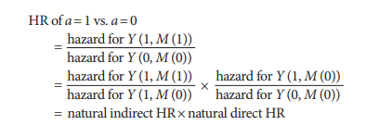

* Supuestos:
  + no confusores no medidos
    - Y (a, M (a)) ㅛ A | C (1a) exposición-resultado
    - M (a) ㅛ A | C (1b) exposición-mediador
    - Y (a, m) ㅛ M | (A, C) (1c) mediador-resultado
  + positividad: para cualquier valor de un confusor, todoss los valores de la exposición tienen una probabilidad mayor a 0; para los valores de la confusión y la exposición, todos los valores del mediador tiene no-zero probabilidad.
    - P (A=a|C=c)> 0 for all a, c (2a)
    - P (M=m|C=c, A=a)> 0 for all a, c, m (2b) ; y equivalente usando densidades cuando A y M son continuos
  + consistencia: garantiza que los contrafácticos anidados estén bien definidos. Sin embargo, si la condición de consistencia no se cumple, entonces no podemos estar seguros de que los valores observados de la presión arterial sean iguales a los valores que se habrían observado si hubiéramos intervenido en el tratamiento y el mediador. En este caso, la inferencia causal puede ser incorrecta.
    - P (Y (A, M)=Y)= 1 and P (M (A)=M)= 1
  + Identificar efectos naturales (4a)
    - Y (a, m) ㅛ M (a*) | C for any m and a≠a*
    - Más difícil de comprender: requiere independencia entre dos distintos mundos contrafactuales (a y a*) son diferentes. 4a puede ser reemplazada asumiendo que no hay confusores de la relación mediador-resultado y que no están afectados estos confusores por la exposición. O, tal vez, más práctico, uno puede asumir que el efecto directo e indirecto son creados por mecanismos distintos y creados por mecanismos causales distintos.
    - Para ver si estas condiciones son suficientes, derivamos una fórmula explícita para E[g (Y (a, M (a*))].
    - La función de medida arbitraria g : R → R es incluida para demostrar que es la distribución total de los contrafactuales anidados que hemos identificado, no sólo la media. Para facilidad de exposición, asumimos que C y M son discretos, con un espacio C y M respectivamente
* SECTION 3: ESTIMATING NATURAL EFFECTS MODELS
  + a regression model for the nested counterfactual
  + Caso ilustrativo
    - Usar los datos originales solos, modelar un modelo de supervivencia paramétrico para el resultado condicionado en confusores, exposición y mediador. Esto puede ser por instancia un modelo Weibull.
    - Construir una base de datos nueva repitiendo cada observación en la base original 2 veces eincluir una variable adicional A*, que es igual a la exposición original para la primera réplica, e igual al opoesto para la segunda
    - Añadir una variable de identificación para indicar qué filas se originan del mismo sujeto
    - Usar la función predict, posiblemente junto con la función de distribución Weibull, para imputar los tiempos de supervivencia para las filas donde A != A*. En las imputaciones, el valor de la exposición se pone A*, mientras los mediadores y confusores se configuran a sus valores osbervados; esto es, imputar los valores para los tiempos de supervivencia Yi (a*, M (a)).
    - Ajustar un modelo Cox para la base extendida incluyendo A, A*, y C, pero no el mediador.
    - El coeficiente de A será el natural indirecto log-HR y el coeficiente de A* será el log-HR natural directo.
    - Repetir los pasos 3 y 4 y combinar los logHRs con imputación múltiple. Es decir, tomar el promedio de los log-HRs. CI para los efectos naturales y por las cantidades derivadas como las proporciones mediadas, pueden ser obtenidos por boostrap, que implica repetir pasos 1-5 un total de 1,000 veces, cada vez creando una nueva base con random sampling con reemplazo de esa base de datos original

SECTION 4: ANALYSING THE ILLUSTRATIVE CASE

<https://biostat.au.dk/ResearchSeminars/Research_seminar_Aarhus_d151118.pdf>

* Mediation analyses might not be a good tool to guide interventions

## Discacciati, A., Bellavia, A., Lee, J. J., Mazumdar, M., & Valeri, L. (2018). Med4way: a Stata command to investigate mediating and interactive mechanisms using the four-way effect decomposition. International journal of epidemiology, 10.1093/ije/dyy236. Advance online publication. https://doi.org/10.1093/ije/dyy236

* + El efecto total de una exposición en un resultado en presencia de un mediador que podría interactuar con la exposición, se puede descomponer en 4 porciones del efecto:
    - no a la mediación ni a la interacción (CDE)
    - sólo interacción (reference interaction)
    - mediación e interacción (mediated interaction)
    - sólo mediación (pure indirect)
  + CDE: El efecto de A en Y al ajustar el mediador a un valor
  + NDE: El efecto de A en Y al ajustar el mediador a lo que naturalmente habría sido si la exposición hubiese estado ausente
  + NIE: Indirecto, el efecto de A en Y sólo si se cambia el mediador
  + Vanderweele ha permitido descomponerlos
  + Total: Ya – Ya*

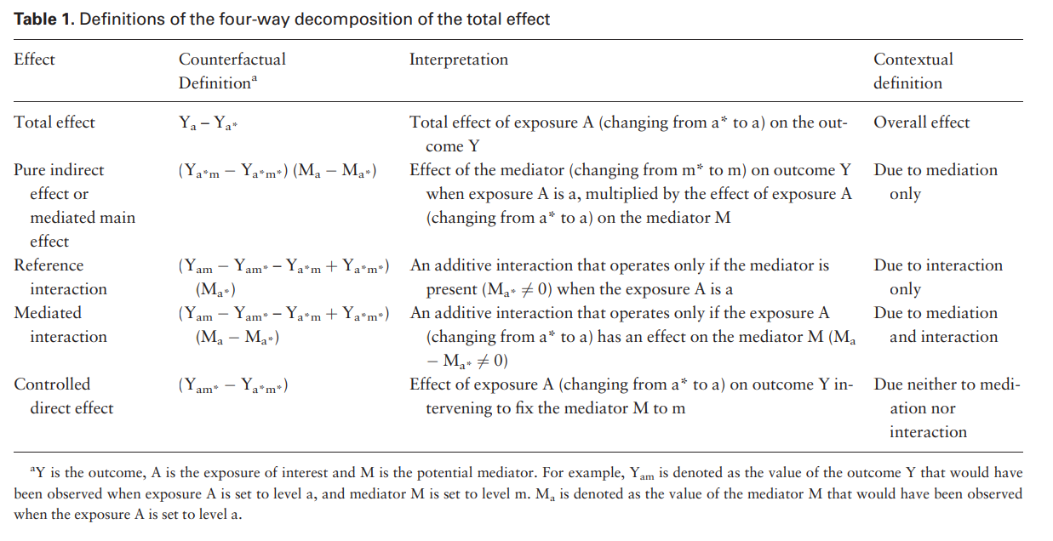

* + Primero, se ajustan dos modelos de regresión: uno para el resultado (como función de la exposición, el mediador, la interacción y sus confusores) y un modelo para el mediador (como función de la exposición y confusores). Las formas de regresión disponibles de los modelos del resultado son lineales, logísticos, log-binomiales, poisson, binomial negativo, AFT (exp y wei) y Cox, y los disponibles en el mediador son lineale sy logísticos.
  + Los efectos causales son computados por el comando como una funciónd e los parámetros estimados de los modelos anteriores. La matriz de varianza-covarianza de los componentes es obtenida usando el método delta o bootstrap no paramétrico
  + Para la variable de supervivencia, no es necesario mencionar el resutlado sino hacer stset antes
    - • a0() - específicar el nivel de referencia de la exposición
    - • a1() - especificar el nivel actual de exposición
    - • m() - especificar el nivel de mediador en el que se computará la descomposición de 4 vías;
    - • yreg() especificar la forma de regresión
    - • mreg() orma de regresión para el mediador}
    - c() fixes the values of the confounders at which to compute the four-way decomposition. If omitted, confounders will be automatically fixed at their respective mean values;
    - fulloutput specifies that, in addition to the four components of the total effect, the following quantities are to be reported: the four proportions of the total effect due to each component, the overall proportion mediated, the overall proportion due to interaction and the overall proportion eliminated. This option is particularly useful when used together with the bootstrap option
  + postestimación
    - calcular combinaciones lineales y nolineales de los componentes y errores estándar lncom lincom
    - Test de wald de hipótesis no-lineales (ej., sobre igualdad de dos componentes) test testnl
    - obtener percentiles, corregidos por sesgo, estat bootstrap
    - mostrar la matriz de varianza-covarianza

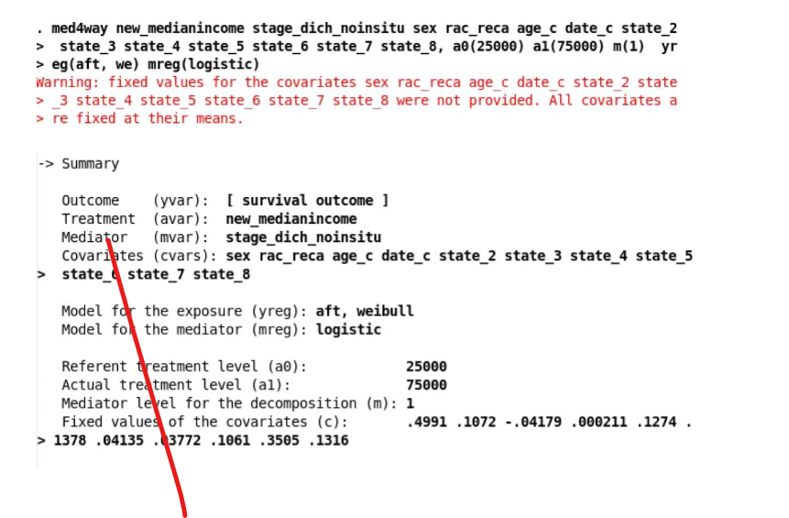

* + - asdasdsadasd

## Rijnhart, J.J.M., Lamp, S.J., Valente, M.J. et al. Mediation analysis methods used in observational research: a scoping review and recommendations. BMC Med Res Methodol 21, 226 (2021). https://doi.org/10.1186/s12874-021-01426-3

* + Se prefiere el análisis de mediación causal ya que provee estimaciones del efecto causal mientras que el tradicional sólo puede probar la existencia de un efecto mediado a penas (VanderWeele TJ. Explanation in causal inference: methods for mediation and interaction: Oxford University press; 2015.)
  + El método tradicional tiene problemas viendo modelos no lineales (ej., Cox) en el el producto de coeficientes o la diferencia en coeficientes. También no ve los casos en que hay interacción entre la exposición y el mediador, cuando el resultado es binario
  + El resultado contrafáctico individual bajo el valor de exposición x se denota como Yi(x), y el resultado contrafactual individual bajo el valor de exposición x se denota como Yi(x).**
  + Los resultados contrafactuales en un modelo de mediación no son sólo dependientes de los valores de exposición, pero también en valores de mediación
  + Two counterfactual mediator values can be observed for an individual under the two exposure values x and x*:
  + The regression-based effects for mediation models with a binary or time-to-event outcome were originally derived on the risk-ratio scale, therefore this method poses an additional rare outcome assumption when the causal effects are estimated on the odds-ratio scale or hazard-ratio scale
  + This assumption requires the outcome prevalence to be low across all strata of the exposure and mediator variable
  + Natural effect models are estimated using a weighting-based approach or a imputation-based approach.
  + The weighting-based approach creates an expanded dataset with weights for each subject based
  + The imputation-based approach creates an expanded dataset in which the missing potential outcome values are imputed based on information from eq. 3
  + when eq. 1 is estimated with linear regression and eq. 2 is estimated with non-linear regression, e.g., logistic regression or Cox proportional hazards regression, traditional and causal mediation analysis only provide the same effect estimates when the mediator follows a normal distribution, the outcome is rare, and interactions are absent
  + Although the bias-corrected bootstrap confidence interval was the most often reported confidence interval in the studies in this scoping review, percentile bootstrap confidence intervals generally perform best in terms of the balance between type I and type II error rates
  + demonstration of the importance of testing the plausibility of the causal assumptions, as this review and previous reviews found that most studies fail to address the plausibility of all causal assumptions [20, 29, 91].

## Survival mediation

#_#_#_#_#_#_#_#_#_#_#_#_#_#_#_#_#_#_#_#_#_#_#_#_#_#_#_#_

#_#_#_#_#_#_#_#_#_#_#_#_#_#_#_#_#_#_#_#_#_#_#_#_#_#_#_#_

mod.y <- survreg(Surv(time_to_off_from_adm, event_offense) ~ event_comp + policonsumo, data = match.data(m.out3))

mod.m <- glm(event_comp ~ policonsumo, data = match.data(m.out3), family="binomial")

med.m <- mediation::mediate(mod.m, mod.y, treat = "policonsumo", mediator = "event_comp",robust = TRUE, sims = 100 )#cluster="" no funciona

summary(med.m)

sensitivityAnalysis <- mediation::medsens(med.m)

#Error in mediation::medsens(med.m) : mediate object fitted with non-supported model combinations

#3.2. Moderated mediation

#passing the object from mediate to the medsens function

#If there exist unobserved pre-treatment confounders which affect both the mediator and the outcome, we expect that the sequential ignorability assumption is violated and ρ is no longer zero.

#sens.out <- medsens(med.out, rho.by = 0.1, effect.type = "indirect", sims = 100)

#where rho.by = 0.1 specifies that ρ will vary from −0.9 to 0.9 by 0.1 increments, andeffect.type = "indirect" means that sensitivity analysis is conducted for the ACME. Alternatively, specifying effect.type = "direct" performs sensitivity analysis for the ADE and "both" returns sensitivity analysis for the ACME and ADE.

#:_#:#:#:#:#:#:

#Single experiment design

#First, the researchers can continue to make the sequential ignorability assumption and nonparametrically estimate the ACME. This approach works only when the mediator variable is discrete.

#:_#:#:#:#:#:#:

#Under the parallel design, the ACME is not point identified without an additional assumption

#The mediation package offers two options via the mediate.pd function.

#Parallel encouragement design

#In many situations, perfect manipulation of the mediating variable may be difficult. In the parallel encouragement design, subjects are split into two separate experiments

#[CREO QUE ESTE ES EL MAS CORRECTO]

# subjects are randomly assigned to the treatment and control conditions and then, within each condition, a subset of subjects are randomly encouraged to have a high or low value of the mediator. Both the mediator and outcome variable are then measured

#_#_#_#_#_#_#_#_#_#_#_#_#_#_#_#_#_#_#_#_#_#_#_#_#_#_#_#_#_#_

#_#_#_#_#_#_#_#_#_#_#_#_#_#_#_#_#_#_#_#_#_#_#_#_#_#_#_#_#_#_

require(mets)

#Thomas H. Scheike and Klaus K. Holst and Jacob B. Hjelmborg (2013). Estimating heritability for cause specific mortality based on twin studies. Lifetime Data Analysis. http://dx.doi.org/10.1007/s10985-013-9244-x

#Klaus K. Holst and Thomas H. Scheike Jacob B. Hjelmborg (2015). The Liability Threshold Model for Censored Twin Data. Computational Statistics and Data Analysis. http://dx.doi.org/10.1016/j.csda.2015.01.014

# comp_cases_Base_fiscalia_v15f_grant_23_24<-

# Base_fiscalia_v15f_grant_23_24[complete.cases(Base_fiscalia_v15f_grant_23_24[,..variables_vector]),] %>% dplyr::mutate(policonsumo=factor(policonsumo), event_comp=factor(event_comp))

#

# weightmodel <- fit <- glm(event_comp ~ policonsumo,

# data = comp_cases_Base_fiscalia_v15f_grant_23_24, family=binomial)

#

# wdata <- medweight(fit,data= comp_cases_Base_fiscalia_v15f_grant_23_24)

#

# aaMss2 <- binreg(Event(time,status)~gp+dnr+preauto+ttt24+cluster(id),data=dat,time=50,cause=2)

# summary(aaMss2)

# aaMss22 <- binreg(Event(time,status)~dnr+preauto+ttt24+cluster(id),data=dat,time=50,cause=2)

# summary(aaMss22)

# #Error in `[.data.frame`(x, i, j) : undefined columns selected

#_#_#_#_#_#_#_#_#_#_#_#_#_#_#_#_#_#_#_#_#_#_#_#_#_#_#_#_#_#_

#_#_#_#_#_#_#_#_#_#_#_#_#_#_#_#_#_#_#_#_#_#_#_#_#_#_#_#_#_#_

#VanderWeele TJ. Causal mediation analysis with survival data. Epidemiology. 2011 Jul;22(4):582-5. doi: 10.1097/EDE.0b013e31821db37e. PMID: 21642779; PMC

#_#_#_#_#_#_#_#_#_#_#_#_#_#_#_#_#_#_#_#_#_#_#_#_#_#_#_#_#_#_

#_#_#_#_#_#_#_#_#_#_#_#_#_#_#_#_#_#_#_#_#_#_#_#_#_#_#_#_#_#_

#h

# This paper presented methods for mediation analysis with a time-to-event outcome that are based on either the AFT model or the Cox PH model. The choice for an effect measure, that is, the hazard ratio from a Cox PH model or the ratio of mean survival times from an AFT model, should primarily depend on the scientific context of the mediation analysis. In other words, the effect measure should match the research question at hand. When using either the Cox or AFT models with any of the two mediation frameworks, it is necessary to check the corresponding assumptions. The PH assumption can be checked using the Schoenfeld residuals test and visual inspection of the graphs based on the scaled Schoenfeld residuals. The Weibull assumption can be checked using either of the following two methods: (1) comparing the AIC from AFT models with different specified error distributions and select the error distribution with the lowest AIC, and (2) visual inspection of the Cox–Snell residuals. A further explanation on how to check the Cox and AFT model assumptions can be found in Kleinbaum and Klein

#_#_#_#_#_#_#_#_#_#_#_#_#_#_#_#_#_#_#_#_#_#_#_#_#_#_#_#_#_#_

#_#_#_#_#_#_#_#_#_#_#_#_#_#_#_#_#_#_#_#_#_#_#_#_#_#_#_#_#_#_

#https://cran.r-project.org/web/packages/mma/mma.pdf

#Yu, Q. and Li, B., 2017. mma: An R Package for Mediation Analysis with Multiple Mediators. Journal of Open Research Software, 5(1), p.11.DOI: https://doi.org/10.5334/jors.160

##Surv class outcome (survival analysis)

data(cgd1) #a dataset in the survival package

x=cgd1[,c(4:5,7:12)]

pred=cgd1[,6]

status<-ifelse(is.na(cgd1$etime1),0,1)

y=Surv(cgd1$futime,status)

#for continuous predictor

data.surv.contx<-data.org(x,y,pred=pred,mediator=1:ncol(x),

alpha=0.5,alpha2=0.5)

temp9.contx<-boot.med(data=data.surv.contx,n=1,n2=2, type="lp")

temp10.contx<-boot.med(data=data.surv.contx,nonlinear=TRUE,n=1,n2=2)

#_#_#_#_#_#_#_#_#_#_#_#_#_#_#_#_#_#_#_#_#_#_#_#_#_#_#_#_#_#_

#_#_#_#_#_#_#_#_#_#_#_#_#_#_#_#_#_#_#_#_#_#_#_#_#_#_#_#_#_#_

#https://cran.uib.no/web/packages/mets/vignettes/mediation-survival.html

# The mediator can

## binomial using glm-binomial.

## multnomial via the mlogit function

# In the below example these are

## mediator: gp.f

## exposure : dnr.f

weightmodel <- fit <- glm(gp.f~dnr.f+preauto+ttt24,data=dat,family=binomial)

wdata <- medweight(fit,data=dat)

aaMss <- binreg(Event(time,status)~dnr.f0+dnr.f1+preauto+ttt24+cluster(id),data=wdata,time=50,weights=wdata$weights,cause=2)

summary(aaMss)

ll <- mediatorSurv(aaMss,fit,data=dat,wdata=wdata)

summary(ll)

aaMss <- phreg(Surv(time,status==2)~dnr.f0+dnr.f1+preauto+ttt24+cluster(id),data=wdata,weights=wdata$weights)

summary(aaMss)

#_#_#_#_#_#_#_#_#_#_#_#_#_#_#_#_#_#_#_#_#_#_#_#_#_#_#_#_#_#_

#_#_#_#_#_#_#_#_#_#_#_#_#_#_#_#_#_#_#_#_#_#_#_#_#_#_#_#_#_#_

# https://cran.r-project.org/web/packages/HIMA/HIMA.pdf

# Zhang H, Zheng Y, Hou L, Zheng C, Liu L. Mediation analysis for survival data with high-dimensional mediators. Bioinformatics. 2021 Nov 5;37(21):3815-3821. doi: 10.1093/bioinformatics/btab564. PMID: 34343267; PMCID: PMC8570823.

#_#_#_#_#_#_#_#_#_#_#_#_#_#_#_#_#_#_#_#_#_#_#_#_#_#_#_#_#_#_

#_#_#_#_#_#_#_#_#_#_#_#_#_#_#_#_#_#_#_#_#_#_#_#_#_#_#_#_#_#_

# https://www.ncbi.nlm.nih.gov/pmc/articles/PMC3204669/

```

## OBS NDP Abril 2023

* Queremos apuntar más a largo plazo, atribuyendo a identificar dónde y cómo poner esfuerzos en promover el completar el tratamiento. La gente que entra a tratamiento no es general. Personalizar, quien sabe

# Descartados

Polysubstance use (PSU) is conceived as the use of multiple substances, generally illicit, over an established timeframe (Connors, 2014), and it is common among people with substance use disorders (SUD) (Liu et al., 2018). People with co-occurring use tend to have more problems in various dimensions compared to single-users. It is related to poorer treatment outcomes, greater SUD severity (Crummy et al., 2020; Quek et al., 2013), and prevalence of polysubstance use tends to be higher among users in contact with the justice system (Ford et al, 2022).

Studies conducted in North America, Europe, and Australia have shown that the use of multiple substances leads to a higher mortality rate (Gjersing & Bretteville-Jensen, 2018), is related to posttraumatic stress disorder (Hassan & Le Foll, 2019), and increases the risk of relapse compared to single-substance use (Gjersing & Bretteville-Jensen, 2018; Wang et al., 2017). Also, the prevalence of polysubstance use was higher among users in contact with the justice system (Ford et al, 2022).

Research on polysubstance use in Latin America is considerably limited (Lalwani et al 2022), and like many studies in the global north, high-risk populations have often been underrepresented (Reyes et al., 2013). An analysis of data from independent studies conducted in six latin american countries found that about 21% of participants reported polydrug use, and males, people aged 18-34 years, from Chile, Uruguay, and Argentina were more likely to report polydrug use after adjusting for age and sex (Reyes et al., 2013). Additionally, different studies in the region have associated polysubstance use with more susceptibility to risky sexual behaviors (Meacham et al., 2018), rurality and unemployment (Lalwani et al., 2022), earlier onset use, socioeconomic difficulties, lower educational attainment, and families engaged in dysfunctional practices (Herrera-Rodriguez et al., 2012). Studies conducted in hard-to-reach populations in Chile have associated polysubstance use with school drop-out, unemployment, sexual risk behaviors, and antisocial behavior (Santis 2007; Olivari et al., 2022; Vilugron et al., 2022).

One major issue that has dominated the field for many years concerns is the role of treatment in patients’ life-course trajectories. The completion of treatment (rather than dropping out or leaving against professional advice or being expelled as a result of misconduct) is an important factor in patients with SUD trajectories. Studies have found that patients who complete treatment have better outcomes than those who leave against medical advice, but completion rates may be influenced by patient characteristics (White, 2012; Andersson et al., 2019 ). According to a systematic review in US veterans, completing a substance use intensive outpatient treatment program is associated with a lower likelihood of being arrested or incarcerated among veterans compared to those who did not (Timko et al., 2020). However,

Understanding the relationship between polysubstance use at admission and contact with the criminal justice system in Chile could inform effective prevention and intervention strategies. This study could provide insight into the effectiveness of substance use disorder treatment in reducing the risk of contact with the criminal justice system among individuals with baseline polysubstance use in Chile. This study contributes to a growing literature on the importance of addressing longitudinal dynamics in SUD patients.

**Falta agregar:**

**Bunting. Polysubstance Use Patterns among Justice-Involved Individuals Who Use Opioids 10.1080/10826084.2020.1795683**

**Bunting.Polysubstance use and re-incarceration in the 12-months after release from jail: a latent transition analysis of rural Appalachian women. https://doi.org/10.1080/00952990.2021.1995402**

-----

In addition, different studies in the region have associated polysubstance use with more susceptibility to risky sexual behaviors (Meacham et al., 2018), rurality and unemployment (Lalwani et al., 2022), earlier substance use onset, socioeconomic difficulties, lower educational attainment, and families engaged in dysfunctional practices (Herrera-Rodriguez et al., 2012).

----

**Design**

We will use a population-based record-linkage retrospective cohort, merging records of adults (18+ years of age) in publicly funded Chilean SUTs programs from the electronic clinical record system (SISTRAT), with the Prosecutor’s Office (PO) data of offenses at the national level between 2010 and the third quarter of 2019. Only de-identified individual-level data will be used for the proposed study; thus, the study is considered of negligible risk and can be exempted from ethics review.

**Outcome variable**

*Treatment outcome:* Completion of treatment: Transformed into a dichotomous variable to indicate treatment completion (1= reasonable accomplishment of treatment goals) or non-completion (0= Leaving against professional advice).

*Contact with the criminal justice system*: From a record in which the patient had an offense that ended with a condemnatory sentence after the treatment outcome at baseline. The date will be the date of the commission of the offense. Time will be measured in years or months.

**Exposure**

*Poly-substance use***:** The report of the individual using more than one primary (main) substance at admission to treatment (including alcohol and illicit drugs) (Font-Mayolas & Calvo, 2022).

**Covariates**: The following potential confounding variables available in the database will be considered: Primary substance at admission, Admission age, Substance use onset age, Housing situation, Macrozone, Pre-treatment criminality, Educational attainment, Municipality of residence rurality classification in 2017 CENSUS, Primary substance use frequency, Psychiatric comorbidity (ICD-10th), Biennial poverty index of the municipality of residence, and Sex. Excluding municipality indexes, the covariates being studied are fixed at the entry of the study.

------

We used a survival framework to calculate the time to event of treatment outcome (tr. completion) and CCJS. All individuals were censored at the end of the study period (November 13, 2019).

The main analytic approach will consider modeling the primary outcomes as a function of the exposure variables through multi-state models (64). We will analyze the different disease pathways and the associations between intermediate effects and a previous one through a parametric multi-state model that allows specifying different distributions, using the multistate package in Stata (v.16, Stata Corp, College Station, Texas) (65, 66). The illness-death model is a widely adopted multistate survival model in which three states are defined: health, illness, and death. In our case, the model would allow for transitions between admission and treatment outcome, treatment outcome (completing treatment) and CCJS, and admission and CCJS (without completing treatment). To account for residual confounding, patients will be weighted by the inverse probability of baseline polysubstance use according to covariates; weights will be truncated at the 1st and 99th percentiles (Cole & Hernán, 2008). As the study progresses, we may incorporate other strategies or models to strengthen the analysis.

The Aalen-Johansen estimator is used to estimate the transition probabilities for a population. These probabilities represent the likelihood of the process of interest in being in a particular state, given that it was in another state at a previous time. Specifically, the probabilities take the form Pr(X(t) = j| X(s) = h), where X(t) is the process of interest at time t, and h and j are possible states of the process X(t).

*Secondary analyses*: We utilized a survival analysis-based approach for conducting mediation analysis, which has been done in previous research (11, 12, 13, 14). To estimate the effects of polysubstance use at admission to baseline treatment on time to contact with the criminal system at 6 months, 1 year, and 3 years, we employed the Stata PREDICT, MEANSURV post-estimation command. This method relies on a fitted flexible parametric model in the case of non-proportional hazards, by selecting spline basis functions, to achieve a high degree of flexibility in estimating the baseline hazard (13). In our analysis, we considered the baseline treatment outcome as the mediator and adjusted for the same covariates used for the inverse probability weights for the multistate model. We calculated the proportion mediated at 6 months, 1 year, and 3 years since admission (i.e., the follow-up period), and estimated 95% confidence intervals (CIs) using the bootstrap method with 2,000 replications. We performed all statistical analyses using Stata v.16 (College Station, TX). Another alternative contemplates using “RISCA”' for multistate models and “WeightIt” package for adjustment using IPWs or “mediation” package for mediation analysis for survival data in R version 4.1.2. Codes and markdowns of preliminary analyses are available at bit.ly/3w9wygJ.

We used a survival framework to calculate the time to event of treatment outcome (tr. completion) and CCJS. All individuals were censored at the end of the study period (November 13, 2019).

The main analytic approach will consider modeling the primary outcomes as a function of the exposure variables through multi-state models (64). We will analyze the different disease pathways and the associations between intermediate effects and a previous one through a parametric multi-state model that allows specifying different distributions, using the multistate package in Stata (v.16, Stata Corp, College Station, Texas) (65, 66). The illness-death model is a widely adopted multistate survival model in which three states are defined: health, illness, and death. In our case, the model would allow for transitions between admission and treatment outcome, treatment outcome (completing treatment) and CCJS, and admission and CCJS (without completing treatment). To account for residual confounding, patients will be weighted by the inverse probability of baseline polysubstance use according to covariates; weights will be truncated at the 1st and 99th percentiles (Cole & Hernán, 2008). As the study progresses, we may incorporate other strategies or models to strengthen the analysis.

The Aalen-Johansen estimator is used to estimate the transition probabilities for a population. These probabilities represent the likelihood of the process of interest in being in a particular state, given that it was in another state at a previous time. Specifically, the probabilities take the form Pr(X(t) = j| X(s) = h), where X(t) is the process of interest at time t, and h and j are possible states of the process X(t).

Secondary analyses: We utilized a survival analysis-based approach for conducting mediation analysis, which has been done in previous research (11, 12, 13, 14). To estimate the effects of polysubstance use at admission to baseline treatment on time to contact with the criminal system at 6 months, 1 year, and 3 years, we employed the Stata PREDICT, MEANSURV post-estimation command. This method relies on a fitted flexible parametric model in the case of non-proportional hazards, by selecting spline basis functions, to achieve a high degree of flexibility in estimating the baseline hazard (13). In our analysis, we considered the baseline treatment outcome as the mediator and adjusted for the same covariates used for the inverse probability weights for the multistate model. We calculated the proportion mediated at 6 months, 1 year, and 3 years since admission (i.e., the follow-up period), and estimated 95% confidence intervals (CIs) using the bootstrap method with 2,000 replications. We performed all statistical analyses using Stata v.16 (College Station, TX). Another alternative contemplates using “RISCA”' for multistate models and “WeightIt” package for adjustment using IPWs or “mediation” package for mediation analysis for survival data in R version 4.1.2. Codes and markdowns of preliminary analyses are available at bit.ly/3w9wygJ.

[use weights in mediation package - General - Posit Forum (rstudio.com)](https://community.rstudio.com/t/use-weights-in-mediation-package/155769)

[Research on Identification of Causal Mechanisms via Causal Mediation Analysis (harvard.edu)](https://imai.fas.harvard.edu/projects/mechanisms.html)

<https://imai.fas.harvard.edu/projects/mechanisms.html>

mostrar trabajo avanzado

**ags → enfocarse más ahí**

Analysing simultaneity of use allows for a distinction to be made between concurrent and simultaneous polydrug use, these being two constructs that correlate but are distinguished at the level of discriminant validity (different intentionality of consumption, for example)

Difficulties in defining different combinations, time intervals and frequencies of each one --> tratamiento difícil de definir